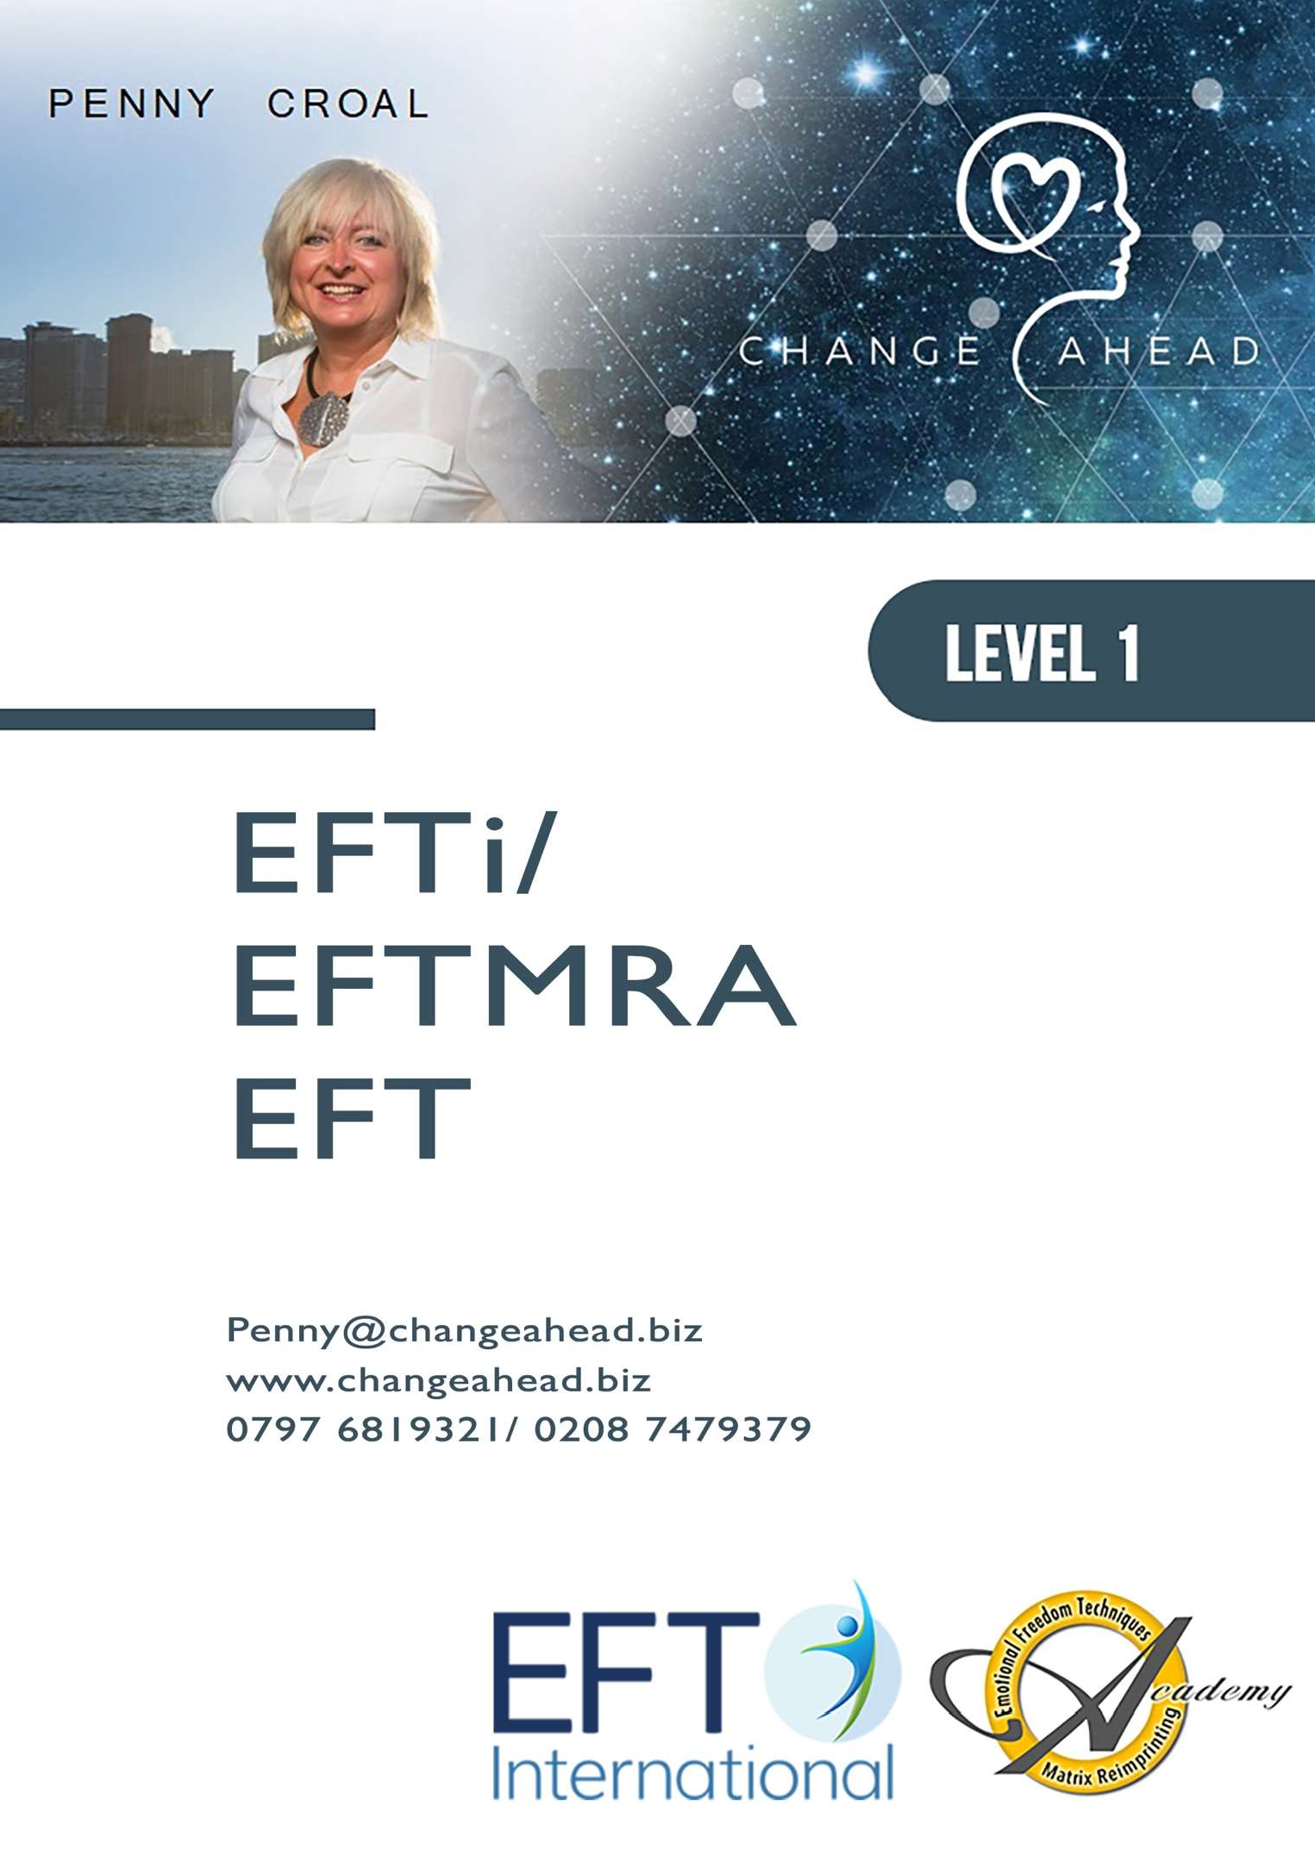

CONTENT
CONTENT 2
HISTORY AND BACKGROUND TO EFT 3
EFT AND ACUPUNCTURE POINTS 14
HOW DOES EFT WORK? 15
COMMON QUESTIONS 18
TAPPING POINTS 21
EFT PROTOCOL 22
SUBJECTIVE UNITS OF DISTRESS 23
PERFORMING EFT 24
EFT FLOWCHART 26
GETTING TO THE PROBLEM 27
OBSERVATIONS 32
WHAT CAN INTERFERE WITH EFT WORKING? 34
TESTING RESULTS 41
EFT FOR TRAUMA 43
ABREACTION 44
EFT FOR PHYSICAL SYMPTOMS 46
ADDICTIONS AND CRAVINGS 47
EFT FOR CRAVINGS 49
BORROWING BENEFITS 50
WORKING ON YOUR OWN ISSUES 53
PERSONAL PEACE PROCEDURE 54
WHAT DO I DO IF I’M NOT GETTING ANYWHERE? 55
USEFUL READING MATERIAL 56
WHAT NOW? 57

HISTORY AND BACKGROUND TO EFT
Introduction
Here we are dealing with what could be termed ‘modern meridian therapies’ – that is the therapies and techniques loosely termed Energy Psychology that have developed in the last two decades. On this basis, by definition, any history must be very short. So we will look at the historical origins of these therapies in order to see their roots and to see them in the true perspective of the thousands of years of development that lies behind them.

Acupuncture & Shiatsu

Fundamentally all energy therapies can trace their earliest origins to acupressure and shiatsu, which therapies developed independently but alongside each other in China and Japan respectively. However, similar therapeutic concepts can be traced in many parts of the world, which are equally as old or older than the Chinese / Japanese therapies.
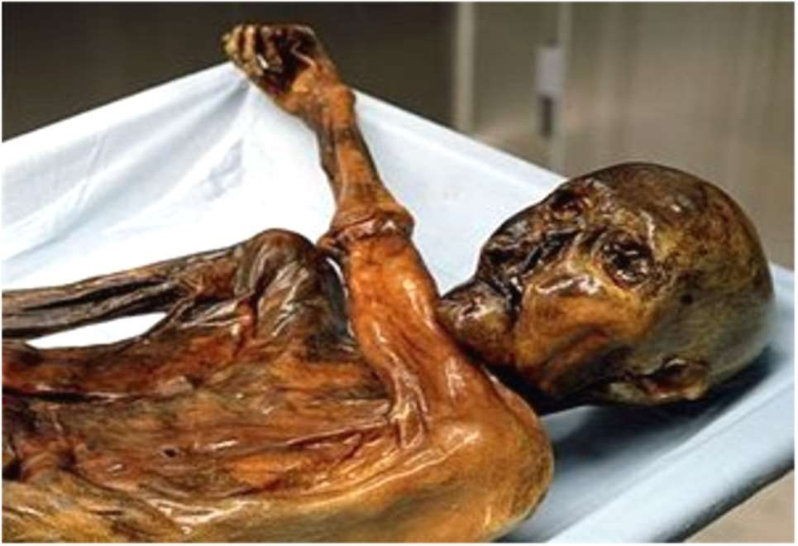
There is evidence of acupuncture like treatment carried out by groups as far apart as the Bantu in Africa and the Eskimo in the Arctic, but these are difficult to date. The earliest well-dated instance seem to be a mummified body found in the Alps in 1991. The body was discovered preserved in a glacier in the Alpine Oetz valley between Austria and Italy. The corpse has been reliably dated to about 3 200 BC, and it carries 15 groups of
tattoos identifying points which can be identified with acupoints corresponding to arthritic pain, which this man had certainly suffered in life.

Early Development in China
Acupuncture is usually considered as a Chinese therapy, and rightly so as it was in China that the therapy was codified and there is a continuous history of acupuncture from at least 1000BC, which continues to the present day.

Between 475 and 221 BC the therapy was consolidated and written into a book known as “The Yellow Emperor’s Classic of Medicine” (“Huangdi Nei Jing”), which describes the meridians in a way which is still recognisable today. It described the use of metal needles, but it is clear that sharp stones and splinters of bamboo had been used much earlier. Development continues in an orderly way and about 400 AD a further book appeared called “A Classic of Acupuncture and Moxibustion”
(“ Zhen Jiu Jia Yi Jing”), which described the acupoints and meridians in detail and in such a way that it could still be effective as a text book in one of today’s Schools of Acupuncture. A detailed study of over 600 acupoints was made during the Sung, Kin and Yuan dynasties (960 – 1368 AD) and resulted in a further descriptive book known as “The Illustrated Manual on the Points for Acupuncture and Moxibustion” (“ Tong Jen Shu Xue Zhen Jiu Tu Jing”). The term ‘moxibustion’ used in the title of these works refers to the stimulation of the acupoints with burning mox (Artemisia japonica). Also

two life sized bronze figure were commissioned, which were engraved with meridians and acupoints. With the book and the figures the therapy spread widely across China and still thrives there, and is now well known and practiced in the West

SCIENCE FINALLY PROVES MERIDIANS EXIST
Article by Azriel ReShel April 20th 2016
“In every culture and in every medical tradition before ours, healing was accomplished by moving energy.” – Albert Szent-Gyorgyi, Biochemist and Nobel Prize Winner.

For centuries the ancient wisdom keepers and healers in several traditions had a keen understanding of the energetic body. The healing traditions from China, India, Japan and Tibet, as well as other countries all spoke of energy channels, meridians or nadis along which the vital energy flowed.

Life was considered to be a bio-electrical and vibrational energy phenomenon and so health revolved around balancing energy through various means. Life existed because of life force and energy running through and animating the body, ensuring we can move, breathe, digest food, think and even feel.
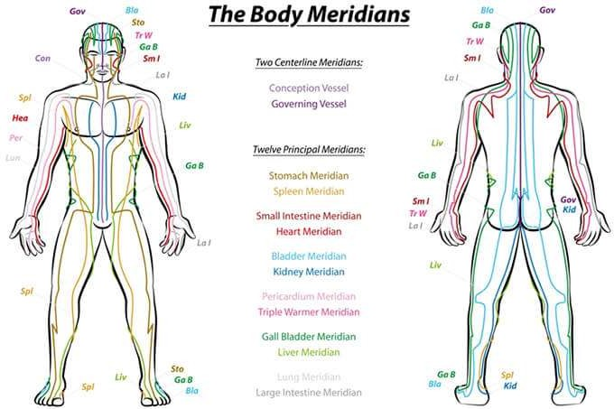

Healing traditions all spoke of energy channels, sen, meridians or nadis.

Energy channels

This vital life force or chi, is composed of two kinds of forces, yin and yang, and flows along a sophisticated network of energy pathways, or highways, circuiting the body. Over 2000 years ago ancient cultures knew of the existence of these energy channels. They were called ‘sen’ in Thailand, ‘nadis’ in India, ‘meridians’, ‘channels’ or ‘vessels’ in China and Japan, and ‘channels’ in Tibet. In India, where many eastern healing arts developed, there were said to be 72 000 nadis or energy pathways. Disease is believed to be a blockage in the energy flow of these channels. A range of healing traditions, including acupuncture, acupressure, massage and yoga, are founded on the principle of the existence of energy channels or pathways, known as meridians, or nadis, running around the body in an expansive network.

While it may seem a little airy fairy to some to consider the energy body while we have flesh and bone, at source we are an energy field, embedded into another energy field. Our bodies are electromagnetic in nature and science has measured these frequencies with advanced machines, like EKG’s and MRI scanning, for many years.

Numerous studies demonstrate these energy pathways and points conduct electricity even when needles aren’t used. And the massage technique of Shiatsu have been found to stimulate the same energetic effects. Similarly, Qigong,Tai Chi and the postures of yoga, have been found to increase electrical conductance at acupoints, yet science never believed in the existence of meridians until now.



A range of healing traditions are founded on the principle of the meridians.

Scientific research

Recently scientists at Seoul National University confirmed the existence of meridians, which they refer to as the “primo-vascular system.” They say that this system is a crucial part of the cardiovascular system.

Previously, North Korean scientist Kim Bong-Han proposed that he had found meridians in the early 1960’s. Dr Kim Bong-Han showed over 50 years ago that new tubular structures exist inside and outside of blood vessels and lymphatic vessels, as well as on the surface of internal organs and under the dermis. He believed they were the traditional meridian lines. The meridians were called Bonghan ducts or channels, after his research, but now the existence of this system in various organs has been corroborated by further research.

The current Korean researchers now believe the primo-vascular system is in fact the physical component of the Acupuncture Meridian System. And it has also been suggested that this system is involved in channelling the flow of energy and information relayed by biophotons (electromagnetic waves of light) and DNA.



There may be a link between the meridians and energy and information relayed by DNA.

The Korean scientists studying oriental medicine with biophysical methods injected a special staining dye which coloured the meridians. By injecting the dye onto acupuncture points, they were able to see thin lines. These did not show up at non-acupuncture point sites where there are no meridians. The researchers discovered that the meridian lines are not confined to the skin, but are in fact a concrete duct system through which liquid flows, and that this liquid aggregates to form stem cells.

Previously, scientists used a combination of imaging techniques and CT scans to observe concentrated points of microvascular structures that clearly correspond to the map of acupuncture points created by Chinese energy practitioners in ancient times. In a study published in the Journal of Electron Spectroscopy and Related Phenomena, researchers used contrast CT imaging with radiation on both non- acupuncture points and acupuncture points. The CT scans revealed clear distinctions between the non-acupuncture point and acupuncture point anatomical structures.



Scientists injected a special staining dye which coloured the meridians.

The meridian system

There are 12 primary paired meridians and two single mid meridians, six yang and six yin. The yang meridians run down the body and the yin meridians flow up the body. Each meridian is also related to an element. Each meridian is most active at a certain time of the day or night and each meridian is influenced by an element or season.

The nature of meridians, in their elemental structure, and as vessels for the life force, show the intricacy and profound connection of our body at a cellular level, to the universe. We are intimately connected by the elements, energetic structure and flow of energy, to all life, at a cellular, physical level. Our earth is also said to have energetic pathways or ley lines, akin to meridians.



The map was created by Chinese healing practitioners nearly 2000 years ago.

How are meridians related to health?

Our bodies need balance. A balanced flow or energy, not too much or too little, is conducive to good health. This is the same in the way we live our lives. Balance is paramount. Just enough food, water and a healthy balanced lifestyle. As the Buddha said: “middle way” or moderation in all things.

We can see this harmony and balance in life, as the balance between the energies of yin and yang – or more simplistically, masculine and feminine – the two opposing and catalysing energies of the universe.
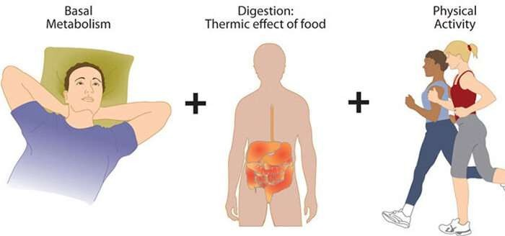

In our bodies we need balance, not too much or too little.

Our health is vibrant if there is harmony and balance between these two forces in the body. If the balance is disturbed, and the flow of one

of these forces becomes greater than the other then illness arises. These forces or energies flow through very definite channels in the body, or meridians, and these are the body’s healing energy pathways.

In traditional Indian medicine, the meridians are expanded upon. There are nadis found within the physical body and these nadis make up the nervous system, the circulatory system, the digestive system, the respiratory system, the lymphatic systems, etc. Any blockages in these nadis can result in physical health conditions. Nadis can also be found in the subtle body where they carry thoughts, feelings, and nerve impulses. When these nadis are blocked, we lose our ability to feel, and connect deeply with others, the environment and ourselves. In the same way that veins and arteries are important for the body to function, nadis weave through our physical nerves and the matrix of consciousness that circuits the mind and self, supporting our physical expression from the otherworldly dimensions of existence.
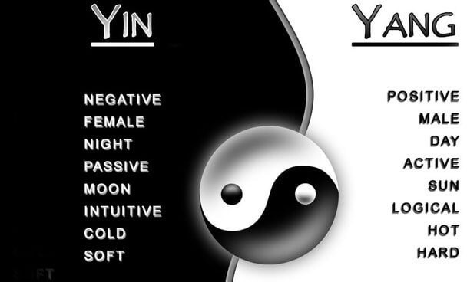

Chi is made up of two kinds of forces, yin and yang.

When the flow of energy is blocked, it causes low energy and illness. Practices like yoga and meditation work on these subtle energy channels, supporting the flow of energy through the body. According to some ancient indian texts there are 350 000 nadis or energy pathways in the body. In traditional Indian medicine and spiritual science, the energies of the physical body, the subtle body and the causal body are said to flow through the nadis. Within this framework,

the nadis are said to connect at special points of intensity called nadichakras.

The three most important nadis are those running along the spine: ida, pingala and sushumna. The Sushumna is the central channel of energy in the human body and it runs from the base of the spine to the crown of the head and carries kundalini energy, which is the primal evolutionary force. Kundalini is awakened through yoga and meditation and is said to lie dormant at the base of the spine.

Activation of the kundalini leads to higher consciousness states. The aim of yoga is to broaden the sushumna and to unite the pathways. Purifying all three nadis leads to overall health, and wellness of body and mind, as well as spiritual growth. Various Pranayama techniques aid in helping to keep these nadi channels open.
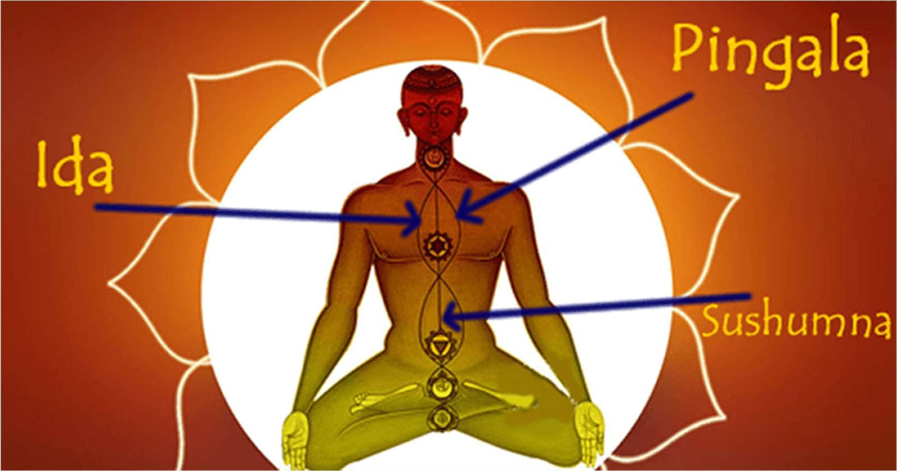

The three most important nadis are those running along the spine: ida, pingala and sushunma.

If you are sensitive to energy and have had energy treatments, such as acupuncture, you may have felt streams of energy or a flow of cold or heat, for example, up the legs or arms. This is a freeing up of energy in the meridians and the flow of energy that is released when a blockage is removed.

There are many wonderful healing modalities based on the meridian system that support radiant health. By enhancing the flow of energy through the body, balance and health is achieved and we come in touch with our true selves. Acupuncture is a therapeutic modality used in China as early as the late stone age. It was used to treat all

ailments affecting people. Acupuncture did not enter modern Western consciousness until the 1970’s when China ended a period of isolation and resumed foreign political and cultural contacts.

The range of applications for acupuncture has grown slowly in the West, possibly because of the belief that it has no scientific

basis. Perhaps now with the scientific proof of meridians, acupuncture will become more widespread for all ailments, along with other great healing modalities based on the energetics of the body, supporting more people to have vibrant health and wellbeing.

Western Acupuncture
In the West acupuncture took two roads. It survived (and still does) in its pure form and it was also taken into Western Medicine. It is from the fruitful fusion of the Eastern and Western ideas that ‘modern’ Energy Psychology techniques sprang. Opioid peptides are released during acupuncture which are the body’s natural painkillers. There is evidence of a similar discovery in India that predates that from China.

Kinesiology
In the mid 1960’s Chiropractor, Dr George Goodheart began to investigate the links between apparent muscle strength, the body’s organs and meridians and he developed a diagnostic therapy based on muscle testing. This work continued drawing on studies by Kendall & Kendall on muscle testing, Chapman & Owen’s work on neuro- vascular reflexes and research by Mann on acupuncture meridians. This work grew into the science of Applied Kinesiology. John Thie, a colleague of Goodheart published a book, “Touch of Health” in 1974 which first brought this combination of ideas to the general public.
Also in the mid 1970’s a psychiatrist, John Diamond, applied his studies of Applied Kinesiology to his work in psychotherapy naming this new field Behavioural Kinesiology.

Thought Field Therapy

TFT began around the 1980s when Dr Roger Callahan (a psychologist) was becoming dissatisfied with the therapeutic models available to him to help patients solve their psychological problems. He had studied Kinesiology with Diamond and was also investigating Eastern health practices, specifically, those that involved the acupuncture meridian points

Dr Callahan experimented on a patient called Mary, who was suffering from a deep and intractable water phobia and who had been receiving therapy without results for some years. A number of “stories” have grown up about the incident that led to Mary’s

cure – some more spectacular than others. However, it is recorded that tapping below her eye while she focussed on her fear of water completely and rapidly removed that fear and the phobia never returned. Callahan spent the next 10 years developing his therapy and named it Thought Field Therapy (TFT). TFT differs slightly from EFT in that it focuses more on “muscle testing” and uses a complicated set of algorithms (tapping sequences) for each different emotion to be treated. At a higher level of TFT, practitioners are also taught a diagnostic process for determining exactly where to tap and are also supposed to use Voice Technology.

TFT practitioner and Clinical Psychologist Fred Gallo reportedly tested the necessity for specific sequences of points on over 500 of his private practice clients and concluded at the end of this that sequence does not matter.

Core Learning Outcomes – EFT Level 1

By the end of EFT Level 1, students will be able to:
- Describe the origins, principles, and theoretical foundations of EFT
- Explain how EFT works from both energetic and psychophysiological perspectives
- Identify and apply the full Standard EFT Protocol and explain its purpose
- Demonstrate the Shortcut EFT Protocol appropriately
- Use the SUD scale and identify emotional intensity accurately
- Apply the Set-Up Phrase and Reminder Phrase with specificity
- Recognise common blocks (e.g., psychological reversal, energy toxins) and know when to pause or adapt
- Explain and manage abreactions or excessive emotional intensity using trauma-aware techniques
- Describe the concept of aspects and how they influence EFT effectiveness
- Conduct a basic tapping session on themselves (self-regulation)
- Begin to use EFT with others under supervision and within ethical limitations of Level 1
- Understand the importance of specificity, testing, and cognitive shifts
- Outline the Personal Peace Procedure for ongoing self-care
- Respect confidentiality and establish healthy practitioner–client boundaries
- Reflect on their own responses, biases, and professional development

Emotional Freedom Technique

“Emotional Freedom Technique (EFT)” was developed by Gary Craig who trained with Callahan in the early years of Thought Field Therapy. Gary Craig streamlined and simplified the complexity of the TFT process and turned it into a single algorithm thus reducing the tapping points considerably. EFT’s emphasis is on the language and linguistic reframing patterns characteristic of NLP. Gary freely gave EFT to the world and encouraged its use by all and to “try it on everything” but with the added caution of “don’t go where you don’t belong.”
On 12 December 2009 Gary Craig announced he was retiring. Here is an extract from his retirement message:-
“ I will be retiring on January 15, 2010. It has been a magnificent ride and I
am thrilled to have joined with you in bringing the EFT gift to the world. I will keep the EFT website, DVD store, Certification and related items active until my retirement date. This should give you plenty of time to make any adjustments you deem necessary.
Please know that our website cannot be maintained by or turned over to someone else. This is because it has my name all over it and thus turning it over, legally speaking, may create unwanted liability for me and my family. Although I am leaving the website open for a while, it remains subject to copyright protection and is not to be copied and reproduced elsewhere.

With this in mind, I am contributing ONLY the trademarked names (EFT and Emotional Freedom Techniques) to the public domain so that you can decide for yourselves how best to use them. Different countries and cultures can establish their own organizations and rules without having to go through me. However, this does NOT include our DVDs, website, the EFT Manual, books and other
materials. They remain my copyrighted property and are NOT being released to the public domain ”

EFT AND ACUPUNCTURE POINTS
In 1992 a study was conducted in France to prove that meridians exist. Over three hundred people took part. A radioactive tracer was injected at acupuncture points, and a special camera was able to image the path. A similar tracer was also injected at a control point that was not an acupuncture point. The tracer injected in the acupuncture points followed the same pathways described as meridians in traditional Chinese medicine.
However, the tracer injected in the random points diffused. Each experiment was repeated several times.

EFT Point |  | Acupuncture Point
Eye Brow | EB | Bladder 2
Side of Eye | SE | Gall Bladder 1
Under Eye | UE | Stomach 1
Under Nose | UN | Governing Vessel 27
Under Mouth | Ch | Central Vessel 24
Collar Bone | CB | Kidney 27
Under Arm | UA | Spleen 17
Thumb | Th | Lung 11
Index Finger | IF | Large Intestine 1
Middle Finger | MF | Pericardium 9
[Ring Finger] | RF | Triple Warmer 1
Little Finger | BF | Heart 9
Karate Chop | KS | Small Intestine 3
Gamut Spot | GS | Triple Warmer 3

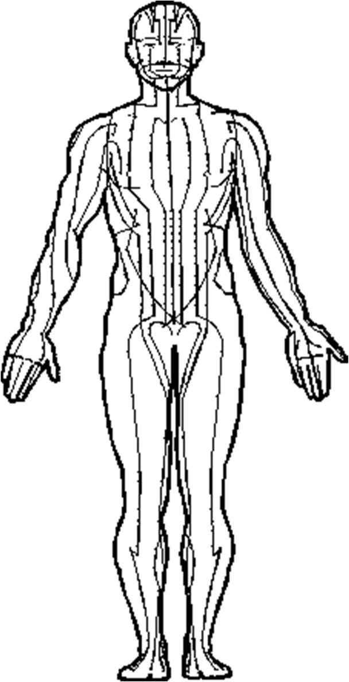
These points are the end points of the major meridians.

Stimulating these points helps move energy around the system.

HOW DOES EFT WORK?


The Discovery Statement “The cause of all negative emotions is a disruption in the body’s energy system”

Conventional psychotherapy presumes a connection between traumatic memories and negative emotions. In fact it’s only when the body’s energy system is disrupted or blocked that it does cause problems. If a disruption in the body’s energy system does not occur, then the negative emotion cannot occur. That is why some people are bothered by their memories and others are not. Why some people have a tendency for their energy systems to become imbalanced under such a memory, while others do not is still a mystery. Talk about a child going from one emotion to the next in a split second

As mentioned above, “the discovery behind EFT is that the cause of all negative emotions is a disruption in one or more of the body’s energy systems (or meridians).” Meridians are pathways or channels on the body that are thought to carry vital energy. Without this vital energy, we would not be alive. It is hypothesised that anything that disrupts or traps this smooth flow of energy is said to contribute to illness and can also cause emotional as well as psychological problems.

For example, a shock disturbs the body because if the body can’t prepare itself, it has no time to use its regular coping mechanism of checking, regulating and balancing. Instead, it has to rely on an emergency response and if this is stored as a memory (in case it’s needed in the future) it will stay there until it can be processed or unless it’s triggered again. The association between the memory and the stimuli can be triggered by any of the 5 senses (see illustration below). The result of the shock basically not only causes an energetic equivalent of a “short-circuit” in the flow of energy but can often cause a disintegration of the right (emotional) brain and left (logical) brain.

Thoughts constantly create patterns of electrical energy that cause the release of neurotransmitters, hormones, and other chemicals in the body that we feel as positive or negative emotions. When a negative thought occurs, it triggers a reaction within the body’s energy system as well as our energy field, similar to tuning into a radio or TV station.

Once the frequency has been picked up, the body’s electromagnetic system is magnified and the disturbance occurs. During EFT we create the disturbance by asking the client to focus on what’s causing the disturbance then tap on the meridians to rebalance. It’s almost like unplugging the radio or TV so it can’t be tuned in. In the illustration below you will see that it is No2 that we use EFT on.

Tuning Fork Metahor



Negative emotion, thoughts and behaviours

1. Memory/Thought 2. Energy Disruption 3. Reaction

Note:
- If there is no disruption or blockage, there is no negative emotion. This includes fears, phobias, anger, grief, anxiety, depression, traumatic memories, PTSD, worry, guilt and all limiting beliefs.
- For the best results find the meaning of the memory
- A memory can be “triggered” by any of the 5 senses and reactivate the energy disruption. As well as a thought

With EFT it is not necessary to relive painful memories or suffer emotionally. Only a brief recall of the problem is required (that may carry some discomfort) but that is all. There is no need to relive the pain. In fact, with EFT, generating prolonged emotional discomfort is frowned upon.

Whilst tapping on specific points on the body, disruptions or blockages in the energy meridian system are removed allowing for a free flow of energy to the body’s cells. As the cells do not hold the memory it is the receptors and the energy field that holds the memories and traumas

Because EFT is also used by teachers, life coachers, priests, counsellors, lay people, nurses etc - how it’s described will depend on the audience of course. Use your judgement but whichever way you choose, always try to keep it simple.

You may hear stories about EFT’s “one minute wonders” and though they do
happen, sometimes it takes a bit more investigative work to establish the root
cause and this requires skill, patience and persistence. Because of this, it
may be best not to oversell EFT with outrageous claims. It’s far better to
lower their expectations and watch their amazement as it works than raise an
expectation that cannot be met.

What Might Act as an Energy Toxin?

- Artificial fragrances, perfumes, detergents, or cleaning products
- Certain foods (e.g. sugar, caffeine, processed ingredients, alcohol)
- Chemicals (e.g. pesticides, cigarette smoke)
- Overwhelm from technology or EMFs (for sensitive individuals)
- Emotional triggers or relationship stressors
- Strongly held limiting beliefs

These substances or stressors may not create a problem in everyone. Energy toxins are idiosyncratic — they are only relevant if they interfere with a person’s response to EFT.

Clinical Relevance

In a clinical setting, the concept of energy toxins can be introduced gently, without reinforcing fear or avoidance behaviours. The aim is not to label everyday items as harmful, but to be curious if tapping is not producing results as expected.

Example:
“Sometimes a particular food, chemical, or stressor might interfere with how well EFT is working for you. Let’s gently explore if anything might be blocking your system right now.”

How to Address Energy Toxins in Practice
- Observe resistance or stuckness
If EFT is not progressing, ask the client about recent exposure to strong fragrances, foods, or environmental shifts.
- Use muscle testing or client intuition (optional and not required in Level 1)
Some practitioners trained in kinesiology use muscle testing to check for energetic disruption, but this is not essential.
- Tap on the reaction itself
If a substance is suspected, you can tap using phrases like:
“Even though my system is reacting to this [perfume/caffeine/emotion], I choose to accept and calm my energy.”
This may help the system integrate and neutralise the response.
- Stay non-judgemental and client-led
Energy toxins should never be used to create fear, rigidity, or obsession with “purity.” Be curious, not dogmatic.

Important Note

EFT does not require elimination diets, detox regimens, or avoiding the outside world. This is a metaphorical lens, not a diagnosis or prescriptive rule. Always prioritise emotional regulation and safety over control-based behaviours

ENERGY TOXIN
“Sometimes in EFT, we come across a session where nothing seems to shift. We’re tapping, staying specific, and following all the steps — but the intensity just doesn’t move. In some cases, this can be linked to something known as an energy toxin — not in a medical or toxicology sense, but as an energetic irritant unique to that person in that moment.

It could be a strong perfume, detergent, alcohol, or even emotional tension they’ve been holding onto. This doesn’t mean those things are ‘bad’ — only that their system may be reacting or overloaded.

If we suspect this might be happening, we can simply ask the body for more information, or gently tap on the interference itself.

For example:
“Even though my system is reacting to something and I don’t know what, I accept where I am right now.”

Always remember: EFT is about calming the body, not controlling it. We use this lens lightly, with curiosity — never to create fear or guilt.”

4.4 Psychological Reversal

Psychological reversal (PR) is a term used in EFT to describe an unconscious internal resistance to healing or change — even when the client consciously wants to feel better. It acts like an energetic “polarity reversal” that blocks progress, often without the person realising it.

This concept was first introduced by Dr. Roger Callahan in Thought Field Therapy and retained in EFT to help explain why EFT sometimes appears not to work.

How to Recognise Psychological Reversal

You might suspect psychological reversal is present when:
- The client says the right words but nothing shifts
- SUDs remain stuck despite correct tapping technique
- The issue seems to get worse with tapping
- The client expresses subtle resistance (e.g., “part of me doesn’t want to let this go”)
- There is strong self-sabotage, guilt, shame, or hidden benefit from staying stuck

When Does It Happen?

PR is most often linked to:
- Deep limiting beliefs (e.g., “I don’t deserve to heal”)
- Secondary gain (benefits to staying unwell, e.g., attention, identity, safety)
- Unconscious guilt, shame, or trauma
- Chronic self-judgment or internal conflict
- Energetic or environmental disruption (e.g., toxins, fear, overwhelm)

How to Address Psychological Reversal

At Level 1, we address PR gently, through setup phrasing and attuned listening — not by force.
- Acknowledge and normalise the block
“Part of me wants to feel better, and part of me doesn’t trust that it’s safe.”
“Even though I don’t want to let this go, I deeply and completely accept myself.”
- Use flexible Set-Up Phrases
Examples include:
  - “Even though a part of me is resisting change…”
  - “Even though I might not deserve to heal…”
  - “Even though I’m afraid of what happens if this goes away…”
- Stay curious and compassionate
Avoid analysing or pushing. PR is often protective — it needs gentle curiosity and safety.
- Tap on the resistance directly
“This part of me that doesn’t want to change.”
“This fear of letting go.”
“This need to stay safe by holding on.”

Summary

Psychological reversal is not sabotage or failure — it is the body’s way of protecting unresolved pain or unmet needs. With gentle awareness and flexible phrasing, EFT can help bring this resistance to light and allow it to soften. We will be focusing more on this in Leve 2

COMMON QUESTIONS



How should I describe EFT?

Emotional Freedom Technique or EFT as it’s known, may also be referred to as Meridian Energy Tapping, Tapping Therapy, Meridian Tapping, Energy Tapping etc but generally comes under the umbrella term of Energy Psychology which refers only to those therapies that use both psychological interventions and energetic interventions together in a particular treatment format. However in USA you cannot say this legally unless you are a clinically certified practitioner/therapist. Personally I would not recommend calling it this, as majority of tappers are not trained psychologists.

Building Bridges to EFT
As a practitioner, one of your foundational responsibilities is to meet clients where they are — emotionally, cognitively, culturally, and spiritually. Clients may come from traditional medical models, scientific frameworks, faith-based worldviews, or holistic traditions. Others may be skeptical, analytical, or unsure. Creating a bridge means offering EFT in language that feels safe, relatable, and coherent with their existing beliefs, without compromising the integrity of the practice.
This is not about persuading — it's about creating resonance.

Creating Bridges: Practical Examples
For clients with a scientific or medical background:
- Frame EFT as a neurosomatic self-regulation technique that uses gentle stimulation of acupoints to down-regulate arousal.
- Reference peer-reviewed studies on cortisol, amygdala deactivation, and PTSD outcomes.
- Emphasise it complements, rather than contradicts, trauma-informed care models.
Example language: “This technique calms the stress response by tapping specific points that signal safety to the brain. It’s been shown to reduce cortisol and support nervous system regulation.”
For spiritually inclined or energetically aware clients:
- Use language like energy flow, meridians, chi, or vibrational release.
- Respect their worldview around ancestral trauma, karmic residue, or intuitive body wisdom.
- Emphasise EFT’s capacity to release stored emotional blocks.
Example language: “EFT helps your energy flow more freely by clearing emotional blockages stored in the body.”
For skeptical or analytical clients:
- Use neutral, experiential framing.
- Emphasise EFT is evidence-based and does not require belief.
- Let their body guide the outcome.
Example language: “You don’t need to believe in it — we’ll just try one round and see how your stress level changes.”

Many people describe EFT as “similar to acupuncture but without needles” “ a meridian based relaxation technique that can decrease anxiety, increase mind-body awareness, and foster cognitive shifts.”or you could say “it adds a more unique therapeutic dimension to other conventional therapies” - all depending on who you are talking to.

Who uses EFT?

- Therapists routinely teach the process to their clients for use at home.
- Teachers are learning it for use with their students and for themselves
- Coaches are learning it for use with their athletes.
- Parents are learning it for use with their children.
- Physicians are learning it for pain management and for phobias with their patients
- Massage practitioners are blending it with their existing procedures for longer and more lasting results.
- Spiritual leaders are applying it to those in need.
- Chiropractors, acupuncturists and homeopathy
- Mental Consciousness practitioners are integrating it into their practices

Is EFT Just a Distraction?
No. EFT is not a distraction — it is an active process of regulation and emotional integration.
Distraction implies temporary avoidance. EFT facilitates emotional resolution through dual awareness: the client stays connected to the emotion while stimulating calming input through tapping. This engages memory reconsolidation, not avoidance.
Scientific support:
- Cortisol reduction: Church et al. (2012) found a 24% cortisol drop in one EFT session compared to 14% for talk therapy.
- Amygdala regulation: Stapleton et al. (2020) showed decreased amygdala activity and increased calm using fMRI.
- Memory reconsolidation: Lane (2009) and others show EFT’s dual stimulation supports deep rewiring of emotional memories.
- Sustained change: Meta-analyses (Clond, 2016) confirm long-term improvement in anxiety, PTSD, and depression.
If EFT were just a distraction, results would not endure. EFT works by helping the body feel safe enough to feel.

What will I experience?

During an EFT session, any or all of the following sensations may be experienced – all which are perfectly normal and natural but should be explained to clients.

- Desire to yawn or sneeze
- Tingling sensation
- Flatulence
- Tightness in parts of the body
- Emotional (sad, angry, grief, shame, fear, etc)
- Feeling hot or cold, (an indication of going cold will let you know that the client is feeling that trauma and is in stress, so it is important to check in on the intensity)
- Feeling light headed/spaced out
- Shaking
- Coughing
- Burping
- Abreaction (discussed later)

When the body’s energy system is rebalanced with EFT, negative symptoms are replaced by healthy functioning. For instance, a phobic response to spiders would be replaced by a calm response to spiders and the aspects related to the phobic response would be normalised. Therefore, physical sensations of distress (e.g racing heart, lumps in the throat or sensations in the pit of the stomach) are alleviated. Disturbed thoughts (such as catastrophic predictions) are normalized. Negative emotions (fear, panic, anger, confusion, etc.) are replaced by inner peace and calm. Unhelpful behavioural tendencies (flight or fight or freeze responses, for example) are corrected. All of this can be achieved through the use of EFT.

CHOICE

What can EFT help with?

A small example

- Anxieties, fears, phobias
- Painful memories, grief and traumatic experiences
- Anger, rage, resentment, jealousy
- Sadness, depression
- Insecurity, low self esteem
- Relationship difficulties
- Performance issues
- Self limiting beliefs/schemas

What research is there on EFT?
This question is often asked but no-one can actually prove how EFT works as many scientists differ in their theories. There have been reviews regarding its efficacy, from anecdotal reports to randomized clinical trials that can be found on the internet or on the Research pages of EFTI International. www.changeahead.biz under resources and Peta Stapleton is showing more current science research. Dawson Church Mind to Matter and many other research is now available
A similar technique to EFT is Eye Movement Desensitisation and Reprogramming (EMDR) which has reached the minimum threshold for being designated as an evidence-based treatment. The latest clinical trial (published in the Journal of Nervous and Mental Disease [2011]) comparing EMDR v EFT for Post Traumatic Stress however proved EFT was as effective as EMDR. It must be borne in mind that because there is still limited scientific evidence and differing theories as to how EFT works, there will still be some scepticism and resistance from those who need gold standard evidence.
However, this doesn’t deter some medical/mental health professionals and complementary therapists from using EFT in their practice.

You can read on some of the trials and studies on the EFT Register website and .org (was EFTI.org) www.eftregister.com and https://EFTiinternational.org/discover-eft/eft-science-research/
What we have to remember

- Does not remove common sense
- Does not replace rational fear or other normal emotions…. it merely removes the excess
- Does not make you an emotional robot
- Does not replace correct medical supervision
- Often works where nothing else will.
- Uses no drugs or equipment.
- Is safe and painless.
- Is usually rapid, long lasting, and gentle.
- Can be easily learned by anyone, even children
- Can be easily self-applied.
- Can be used at anytime, anywhere.
- You don’t have to believe in EFT for it to work

Handling Excessive Emotional Intensity (Including Abreactions)
EFT tapping is designed to help regulate emotional responses safely and gently. However, strong emotional reactions may still arise especially when unresolved trauma is touched. It's essential that practitioners know how to prepare, identify, and respond to these moments with skill and confidence.

Step 1: Pre-frame for Safety
Before beginning any emotionally sensitive work, inform the client that EFT is not about reliving trauma. Make clear that they remain in control.
Example: “We’re not going into the trauma or reliving the event — just lightly tuning into what’s emotionally present. You stay in control the whole time.”

Step 2: Recognise Abreaction
An abreaction occurs when the client becomes overwhelmed and begins to re-experience the trauma as though it is happening in the present. This is more than emotional expression — it’s a survival response.
Common signs:
- Sobbing, hyperventilation, or loss of speech
- Freezing, shaking, collapse, or dissociation
- “I can’t breathe,” “I feel like I’m back there,” “It’s too much”

Step 3: Understand Why It Happens
- Memory accessed too quickly or intensely
- Client not grounded or already dissociative
- Emotional material surfaces unexpectedly
- Practitioner bypasses safety pacing unintentionally

Step 4: Respond with Regulation Techniques
When intensity spikes, shift focus to containment and grounding.
Immediate actions:
- Break state immediately. Ask the client to:
  - Open their eyes
  - Name five things they can see
  - Stand up or hold a cold object
- Pause the story or memory. Do not ask further questions or continue content.
- Ground and co-regulate.
  - Slow your tone and body language
  - Use present-moment orienting: “You’re here now. That memory is not happening.”
- Use non-specific, calming tapping phrases.
  - “This overwhelm” or “This is too much”
  - Avoid naming trauma details
- Avoid touch unless pre-agreed. Even comforting contact may feel unsafe in high activation states.
- Model regulation.
  - Tap with them (real or mimed)
  - Use Box/Container Technique
  - Walk or stretch to discharge energy

Step 5: Language That Reassures
“You’re safe right now. That memory is not happening.” “You don’t have to go any further.” “Let’s stay with what’s present. You’re in charge.”

Step 6: Aftercare
- Offer water or grounding objects
- Let them rest or pause in silence
- Refrain from discussing or analysing the trauma
- Make factual notes for supervision
- Refer to trauma-informed support if patterns repeat

Summary
EFT should never push a client into overwhelm. Your role is to create a safe field where even intense responses can be held, not forced. When managed skillfully, abreactions are not failures — they are protective expressions of a system that can now begin to heal.
Handled with calm, attuned presence, these moments can build lasting trust and nervous system resilience.

Emotional overwhelm is a natural response to deep material not a failure of the technique. Handled with calm, attuned containment, these moments can build trust and long-term healing potential.
EFT is never about pushing someone through trauma. It is about giving the body permission to release safely, with the support of compassionate presence and steady pacing.
EFT tapping is a gentle yet powerful method for emotional regulation. However, when emotional intensity becomes overwhelming, it’s critical to know how to respond safely and confidently.
Always pre-frame: EFT is not about re-living trauma. Clients do not need to dive back into the memory.
“We won’t be going back into the event. Just lightly tuning into what’s here now. You’re in control the entire time


.”

TAPPING POINTS
Tapping various different parts of your body is central to practicing the energy therapy, Emotional Freedom Technique. This figure illustrates all the tapping points but are not necessarily used during an EFT session. Practice where these are before moving onto the next part.
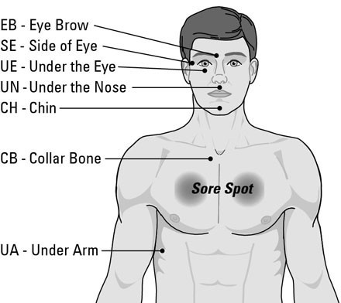
ToH – TOP OF HEAD

This figure illustrates the tapping points on the finger and gamut (the crease on the back of your hand between your little finger and ring finger). Note that all the finger points are on the outside edge of the finger where the nail meets the skin.
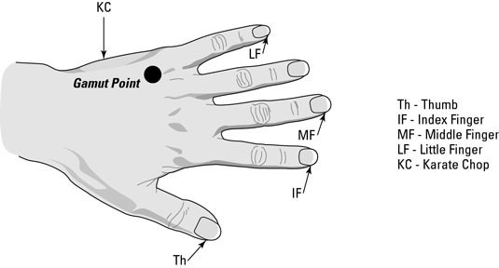
Copyright “EFT for Dummies”

EFT PROTOCOL
Below is the Full EFT Routine. The newer version of EFT reduces repeating the Set up Phrase to once instead of 3 times this is useful when client is in high intensity also omits the finger points, gamut and humming and counting. Practitioners tend to use these points when in difficulty or the clients are stuck, so are included here.

Identify the Problem and Measure it.
Identify, “tune in” and measure the intensity of the problem (belief, emotion, physical feeling) on a scale from 0 to 10 (see SUD scale below).

- Create a Setup Phrase ... while tapping the Karate Chop (KC) point/ Side of Hand state what the problem is (as shown in brackets) and begin with “Even though…” then follow this with an acknowledgment. Example: “Even though I have this (anger)…. I accept myself (acceptance)” or “Even though I have this (anxiety) I
- The Sequence ... Tap on each of the following energy points while naming a shortened description of the problem (reminder phrase). Example:

Top of the Head (ToH) “this anger”
Eyebrow (EB) “this anger”
Side of eye (SE) “this anger”
Under eye (UE) “this anger”
Under nose (UN) “this anger”
Between lip and chin (CH) “this anger”
Collar bone (CB) “this anger”
Under Nipple (UN) “this anger”
Under arm (UA) “this anger”
**These points can be omitted as per the newer version of EFT**
- Finger Points
Tap on the outside of each finger nail (except the ring finger) whilst repeating the “reminder phrase”.
- 9 Gamut
Whilst tapping in-between the little finger and the ring finger (Gamut spot):-

  - Close eyes, Open eyes
  - Without moving the head…look hard down to the bottom right, bottom left then…..Top right and top left
  - Hum any tune for about 3 seconds
  - Count to 5 out loud and Hum again
- Repeat The Sequence again to under arm.

Test what number the SUD is. If the intensity hasn’t gone down to a zero, repeat the Set up (Step1) and Sequence (Step 2) only (not finger points or Gamut). If still no reduction, read your notes or read

“What if I’m not getting anywhere?” later in this manual.

SUBJECTIVE UNITS OF DISTRESS






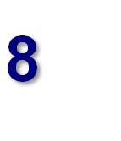












 Extremely intens
e

e!
10

9

7

6

5

4

3

2

1

Very intense
8

Moderately intense



Yippee – gon

Addition of the EFT International Standard EFT Protocol

The EFT International Standard EFT Protocol provides a consistent framework for applying EFT across personal and professional settings. This structure helps ensure safety, clarity, and effectiveness — particularly when supporting clients with varying levels of emotional resilience.

While variations exist across different styles of EFT, the core protocol remains the same and should be taught and demonstrated clearly at Level 1.

Standard EFT Protocol Steps
- Identify the Issue
Invite the client to name a specific issue or feeling. Keep the focus on one event or emotion at a time.
“What would you like to work on today?”
- Measure the Intensity
Use the Subjective Units of Distress (SUD) scale (0–10) to assess emotional charge.
“When you think about that, how intense does it feel now?”
- Set-Up Statement (While Tapping the KC Point)
Use the full set-up phrase three times:
“Even though I have this [issue], I deeply and completely accept myself.”
Modify for client comfort:
“Even though I feel anxious, I’m okay right now.”
- Reminder Phrase
Create a short version of the issue for use during tapping.
“This anxiety” or “This tight feeling in my chest.”
- Sequence of Tapping Points
Tap approximately 7 times on each of the following points, using the reminder phrase while the client stays connected to the issue.
  - Top of Head (TOH)
  - Eyebrow (EB)
  - Side of Eye (SE)
  - Under Eye (UE)
  - Under Nose (UN)
  - Chin (CH)
  - Collarbone (CB)
  - Under Arm (UA)
- Pause and Re-Test SUD
Ask the client to check back in.
“What number is it now?”
If the intensity is dropping, continue. If not, explore for aspects, reversals, or blocks.
- Repeat as Needed
Continue with adjusted reminder phrases until the issue resolves or shifts into another layer.

Why the Standard Protocol Matters
- Safety: Keeps sessions structured and contained
- Clarity: Helps clients follow a predictable process
- Effectiveness: Ensures key elements (focus, testing, regulation) are not skipped
- Transferability: Builds professional consistency across trainers and practitioners

Core Learning Outcomes for EFT Level 1

By the end of Level 1, students will be able to:
- Describe the origins, principles, and theoretical foundations of EFT
- Explain how EFT works from both energetic and psychophysiological perspectives
- Identify and apply the full Standard EFT Protocol and explain its purpose
- Demonstrate the Shortcut EFT Protocol appropriately
- Use the SUD scale and identify emotional intensity accurately
- Apply the Set-Up Phrase and Reminder Phrase with specificity
- Recognise common blocks (e.g., psychological reversal, energy toxins) and know when to pause or adapt
- Explain and manage abreactions or excessive emotional intensity using trauma-aware techniques
- Describe the concept of aspects and how they influence EFT effectiveness
- Conduct a basic tapping session on themselves (self-regulation)
- Begin to use EFT with others under supervision and within ethical limitations of Level 1
- Understand the importance of specificity, testing, and cognitive shifts
- Outline the Personal Peace Procedure for ongoing self-care
- Respect confidentiality and establish healthy practitioner–client boundaries
- Reflect on their own responses, biases, and professional development
- Here is a Self-Evaluation Template designed to match the 15 Core Learning Outcomes for EFT Level 1. It’s formatted for student reflection and trainer review — and can be printed or added directly to your manual:

PERFORMING EFT


What do I say? Many people get hung up about what words to say when formulating the set up phrases believing it’s the words that elicit change. Due to many practitioners using their own words and not listening and repeating back the same words. The rapport will be lost, the practitioner will be projecting on to client, and the energy will not be there. It’s important to mention here that it is getting to the “core issue”
[the underlying problem that supports the beliefs, emotions, thoughts, physical sensations] that truly brings about positive change. Teaching on this is given in detail in Level 2. Meanwhile, some guidance on formulating phrases is given below.

There are infinite possibilities when creating the wording of the Set Up Phrase or Affirmations. The golden rule is to formulate the wording depending on the problem and use the clients terminology, then pair the negative feeling or thought with a positive while you are tapping the karate spot. Then tap on the remaining points using negative statements.

Why tap on the negative? An essential component of the EFT Set up is to accept that you have a problem. The Set up helps us accept our truth (even if we don’t like it) and, by doing so, enables us to take the first step to resolving it. Using a positive before dealing with the major parts of the negative issue is like ignoring the roots of the problem - much like pulling a weed out and leaving the roots doesn’t get rid of the weed. Using the EFT Set up on what you really feel while still accepting yourself anyway allows you to address and resolve the problem.
What do I tap on? If someone had a fear of spiders, you can tap on what they don’t like or are scared of (example their legs, how they run etc) or how they feel, what they believe etc. Results can be achieved this way but if the SUD levels aren’t going down despite your best efforts, or it comes back, then you will need to dig deeper. See “Getting to the problem”.

SET UP PHRASE CONSISTS OF….

Set up phrases are performed whilst tapping the Karate Chop. It may seem strange to focus on the negative but they’re designed to help bring up the intensity so EFT can get to work. The generic “even though” and “I accept myself” are generally accepted words that have shown to work which is why we use them. At Level 2, when you have become a little more confident with EFT, you will be taught how to achieve success quicker from finding the core issue.

A description of the problem - followed by a Self Acceptance or some other form of validation of self or problem e.g “Even though I have this “X” problem….I deeply accept myself” or “Even though I have this “X” problem……I acknowledge this problem.” The Set up also helps overcome any resistance to EFT working.

Problem “Even though….. | Affirmation of self or problem
…I have this fear at the sound of his voice…. | …I want to feel OK”
…I have this anxiety at the thought of meeting her for the first time…. | …..I want to be calm”
…this anger is causing me pain….. | …..I accept my anger and want to let it go”
…..going into that room fills me with dread | …..I’m doing the best I can”

THE SEQUENCE

The Sequence is the tapping points from the top of the head to under the arm. Whilst tapping on these points it’s necessary to keep tuned into the negative emotion so a short reminder phrase is used which is a shortened version of the Set up Phrase. Example

If Set up phrase is “Although I have these butterflies in my stomach.. I accept myself”….
Reminder phrase would be…..“butterflies in stomach”
If Set up phrase is “Even though I have this fear of spiders and their long legs, I accept myself” ………….

Reminder phrase would be…….“spider’s long legs” or “fear of those long legs”

We can vary these words slightly so as to avoid repetitious boredom however we don’t want to jump around several different aspects (covered later)

Be aware “Triggers” that set off the emotion, behaviour or belief. These can be any or all of the following:-
- Senses: what they see, hear, or smell
“Even though the smell of roses reminds me of my mother, I truly and

deeply accept myself”. “Even though the sound of that music makes me sad…..I want to let this sadness go”
- Emotions: anger, sadness, fear
“Even though I’m angry because that driver didn’t stop……I accept myself anyway.”
- Physical: heart racing, legs shaking,
“Even though my legs shake when I go into that meeting, I deeply accept who I am”
- Behaviour: want to run away, need to hide or jump out of the way “Even though I want to run away when I see that man, I want to stay calm”.
- Belief
“Even though I’m not good enough….I want to accept myself one day.”
- Gesture: raised hand, sudden movement, certain look
“Even though that movement scares me…..I want to remain calm”

By saying the Set up phrase, this allows the person to focus on the problem and put it into perspective.

These concepts may be difficult for some, but remember, it doesn’t matter if the statement is believed or not.
The affirmation of “I deeply accept myself” is easy to remember and seems to work but if embarrassed or there are low self- esteem issues, try :-
“I’m OK”
“I like myself, I’m alright” “Deep down I’m alright”
“I acknowledge who I am” “I honour my feelings”
“I’m doing the best I can”

ADDITIONAL LEARNING POINTS

- Say the Set up phrase out loud if you can and with real meaning
- Tune into the feeling as you say it
- You can change sides during tapping
- You can tap on both sides simultaneously
- If you tap in the wrong order, you will find that EFT can be very forgiving
- You may find that after using EFT for a while that tapping on “one point” works for you
- For further help in designing phrases, refer to “Getting to the Problem”.

EFT FLOWCHAR
USE EFT SET UP PHRASE AND TAPPING ROUTINE*

*Full routine or shortcut version
COMPLETE RELIEF
If SUD down to zero, can go back to top of Flowchart and work on another problem. If more Aspects come up. Go to top of Flowchart.
NO RELIEF
Go through manual. If shortcut used – go back & try full routine inc. fingers. If all else fails – seek expert help
PARTIAL RELIEF
Use EFT protocol again
IDENTIFY PROBLEM AND RATE IT USING SUD SCALE
Be specific & use their words.


GETTING TO THE PROBLEM

Results can sometimes be achieved by working on the surface symptoms only but if little or no progress is being made, then it’s important to ask those all important questions to arrive at the CORE ISSUE which underpins the more superficial levels of the client’s problem. Sadness, Anger, Depression are all “symptoms” of the underlying problem.
With EFT we remove layer after layer like peeling layers off an onion, and with the crying that goes with it! For instance a problem with sleeping at night may reveal after questioning that the real issue is a fear of being alone. Basic EFT on its own is not often sufficient and often you will need to establish what the underlying cause is and this requires detective work by questioning to get to the specifics (see below).

- “What’s your first memory of being ignored or rejected?”
- “How do you know you have this problem?”
- “Where or who do you think it originated from?”
- “What sets that off/what does it remind you of?”
- “What do you have to think about to feel like that?”
- “When (or where, or with whom) does it happen worst?”
- “How do you know you are afraid?”
- “And what feeling do you get when you say those words?”
- “Where do you feel that in your body?”
- “And then what happens?”


BE MORE SPECIFIC. Imagine being asked to find a girl called Mary Ford in the UK or USA…..it would be pretty difficult without knowing the exact address! Same with a problem in that we need to know a bit more information to find it.

Clients almost always portray their issues in global terms like, "I feel abandoned", "I’m useless" or "My self image is poor."
However, none of these broad issues could arise unless there were specific
events underlying them. We call those broad issues, GLOBAL terms.

You could use EFT on the global issue and you might get there….eventually but you’ll get there much quicker if you ask for directions (questions). Small examples are below but Level 2 goes into greater detail and teaches the “Movie Technique” which is useful for getting to specifics.

Example of global statements and sample questions:-

C: "My father abused me."
T: “Any specific memory come to mind?”
C: “He beat me when I failed my entrance exam”

C: “I have this fear”
T: “What does it relate to?”
C:” I get it when I get in a lift and the doors close”

C: "I feel rejected”
T: “Why do you think you feel rejected?” C: “My mother left home when I was 5”

Remember:

Use people’s names, specify what, where and how the problem is causing the negative emotion. Instead of saying “I have this fear of heights” try changing it to what caused it “Even though I fell from a ladder when I was 10” for instance. If the original memory can’t be recalled, it doesn’t matter, tapping will usually bring it to the surface anyway and if it doesn’t EFT will still work. If the client is feeling safe and has good rapport with you.

GENERALIZATION After you have used EFT to neutralize the relevant aspects, specific events or a certain theme, the positive effects tend to generalize across related issues. This is because these related events have commonalities.

For example, someone who has 20 traumatic memories usually finds that, after using EFT, the intensities tend to vanish for all of them after neutralizing only a relatively small number. Working on the most significant memory, usually the earliest, tends to offer the best results.

More sophisticated methods are covered at Level 2.

ASPECTS are the “parts” of a problem that contribute to the “triggered” response and support the belief. Here is an example of the various aspects around a fear of flying. Notice how they can be associated with an event, belief or emotion and see if you can you identify which they are and how they can help you establish the core issue?








Fear of
Fear of
Sound
Not in
Turbulan
It will fall
Cannot
News
What
Feeling

When working with aspects, start on the biggest aspect or the one that has the most intensity and ensure the SUD is reduced to a zero. If the intensity goes up after a round, then it’s possible another aspect may have emerged and come into conscious awareness or there is a hidden aspect outside of conscious awareness. A skilled Practitioner will seek these out by asking what, if anything could still be causing distress. If they don’t know, try guessing. Even when the SUD has gone, always check if there could be anything else that might contribute to the problem. A fear of spiders may be appear to have gone but if you ask the client to imagine a spider running across the room, you may get a different reaction! Remember, an aspect could be an emotion, a belief or an event. With a trauma, there may be many aspects such as the sound of the police siren, smell of fuel, belief they are not safe. These all need working on.

Thorough testing will reveal if there are any aspects left. “Shifting aspects” will be taught at Level 2.
TEST TEST TEST

APEX EFFEC  When an issue collapses quickly, it can be difficult for clients to accept this – especially if they’ve been seeking help for years. Sometimes they react by attributing the change to something else (being distracted by tapping) or they deny having the problem or that it wasn’t as intense. People also hang on to their own beliefs and if EFT doesn’t fit in with those beliefs, they may reject it’s efficacy. Try to describe EFT in a way that fits in you’re your client’s beliefs. Never argue with their beliefs but you could write down the problem and the SUD rating at the beginning to demonstrate the changes after the tapping.
T

ADDITIONAL LEARNING POINTS

- When you have the specifics, you can help the client to formulate the Set Up Phrases and Affirmations more easily
- An Aspect can be an emotion, event, belief or physical sensation
- At the end of each round, test on each of the Aspects and see if there have been any changes either positive or negative.

- Be vigilant of any other hidden Aspects.

- Other measurement tools, apart from the SUD scale will be discussed at Level 2.

OBSERVATIONS


Any good practitioner should be observant and alert to changes in the client’s body language as it indicates whether they are feeling better, worse or are showing other signs of change. During EFT, new memories or different Aspects will often surface and can affect a client’s emotional state. These should be watched out for so they can be addressed.

Also observe any changes in your client’s skin colour, posture or voice and react accordingly. For instance, if your client’s mouth is downturned and he/she is slouching whilst saying they’re OK about the memory then there are clearly conflicting messages being sent so ask how they’re feeling.
Sometimes you may notice changes before they do.
Important: Some clients may “abreact” (become very highly emotional and almost panicky). This can happen when intense emotions have been buried and repressed. (Read on Abreactions)

Overall Impressions

Posture/Body position, fidgeting Leg bouncing or tapping Muscular tension
Facial Expression
Gestures and movement of body parts Inconsistencies
Dress, Grooming, Colours Sweating

Movement

Head/neck Torso, shoulders Eyes, lips Hands, feet

Breathing

Shallow or fast breathing Regularity/irregularities

Facial expression
Smiling, frowning, grimacing, Sighing, laughing, yawning Expression of calm
Tears of relief or release Posture, movement or colouring

Voice
Tone, pitch, volume, shaky Feelings of change Tummy calmer
Breathing easier Emptiness no longer there Calm and peaceful Anger/Fear dissipated

If your client’s expressions do not match up with what they tell you (saying they are OK with the problem but are showing distress in their body, this may indicate internal conflict and further hidden aspects should be investigated.)

Cognitive changes

Emotion is also a cognitive process and when using EFT, your client activates their everyday knowing, thinking and understanding. At the same time they experience a change in how their conscious and unconscious minds communicate with each other. This leads to a logical and rational understanding of the problem. Clients may refer to the memory as…

  - That seems silly and insignificant now
  - No, it wasn’t my fault
  - It’s in the past, what’s the problem?
  - It’s like it happened to someone else.
  - I’m keen to give it a try now
  - I feel sorry for her
  - It seems far away
  - It’s all blurred
  - I feel different about it (Check if it’s a good or bad feeling!) More on cognitive changes/shifts are covered at Level 2.

33

WHAT CAN INTERFERE WITH EFT WORKING?

POLARITY
Polarity Therapy was developed by Dr. Randolph Stone, DO, DC, ND (1890-1981)
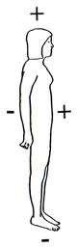
When our electromagnetic field is disrupted, which apparently it can easily be… Energy Psychology treatments appear to not work, or they temporarily work but don't last. -Drs. D. & R. Grudermeyer

What is it?

Every organ and cell in your body is polarized (like a miniature battery) and a person’s health is determined by the natural flow of energy through the body. Polarity refers to the positive and negative charges of the body’s electromagnetic energy field.
EFT helps with this flow and thereby induces restoration of the body’s energy system. Every movement and thought involves electrical activity. When a negative force is introduced into the body’s energy system (see below) then it can disrupt this energy or put your polarity into reverse (similar to batteries being put the wrong way into a device).

Here is an excerpt from an article from emofree.com by Bob Vaughan explaining Psychological Reversal in much more depth
The Setup as a label for the more technical phenomenon known as Psychological Reversal (a term coined by Dr. Roger Callahan but originally brought to the public by Dr. John Diamond). This is a fascinating discovery on its own and deserves special treatment in this course. Did you ever wonder why

….athletes get into slumps?
This defies normal logic. There is no physical reason for them to perform so far below par. The athlete is the same highly trained person before, after and during the slump. But all athletes go through this many times in their careers. Why?
….addictions are so hard to overcome?
After all, the addict usually wants to be free of their destructive patterns. They know, and will often admit, that their addiction is costing them their health, their relationships and even their life! Yet they continue with it. Why?
….depression is so hard to correct?
It is one of the most difficult psychological issues to handle. If one goes for conventional therapy to get over depression they are usually in for years of expensive procedures. And progress, if any is made, is usually accomplished in baby steps. Why?
34

….we sometimes self-sabotage ourselves?
When we try, for example, to lose weight or read faster we often manage to “stop ourselves” and fall back into our previous “comfort zones” with little or no real progress. Why?
….healing sometimes takes so long?
The lingering cold that just won’t go away, the sprain or broken bone that takes forever to heal, the headache or pain that stays and stays. Sometimes things just don’t heal normally. Why?
The reason is in the body’s energy system. It is the actual cause of what is commonly called self sabotage. It is the reason why we sometimes seem to be our own worst enemy and don’t reach those “new levels” we truly want. In addition to the above examples, it is also why people often try in vain to make more money and fall short in countless other pursuits even though they know they have the ability to achieve them. It is also a contributor to psychological blocks (like “writer’s block”) and learning limitations (like dyslexia).
Before this discovery, people’s seeming inability to make progress in areas that are obviously important to them was blamed on such things as “lack of will power”, “poor motivation”, “spacing out” or other forms of supposed character defects. But this isn’t so. There is another cause….and it is correctable.
Psychological Reversal (PR for short) is that cause.
It is an immensely important and practical discovery that is finding its way into several disciplines. It is vital in psychology, medicine, addictions, weight loss, and countless fields of endeavour including sports and business performance.
Where PR is present, little or no headway will be made. It… literally blocks progress.
What is Psychological Reversal? Everyone experiences it. It occurs when the energy system in the body changes polarity and it usually happens outside your awareness. You don’t ordinarily “feel” it happening. It is a literal polarity reversal in your body’s energy system and is like having your “batteries in backwards” as explained in EFT Part I.

Interestingly, it often takes the form of what psychologists call “secondary gain or loss.” For example, the person who consciously believes that they want to lose weight will often have an unconscious “stopper” such as, “If I lose weight I will only gain it back again and that will cost me a lot of money in changing my wardrobe.” This person is psychologically reversed against losing weight.
How was PR discovered? Psychological Reversal has its roots in a field known as Applied Kinesiology. One of the tools of this discipline is known as muscle testing. Here the patient rigidly extends an arm straight out from the side of his or her body while the doctor pushes down on it to assess the patient’s strength. The doctor then has a dialogue with the patient and pushes down on the arm as the patient makes statements. If there is a subconscious disagreement with the statement, the muscles go weak and the arm is easily pushed down. Otherwise, the arm remains strong. This allows the doctor to “talk to the body” and thus help diagnose where problems might reside.

Dr. Roger Callahan was using this procedure with a lady who wanted to lose weight. For perspective, here is how he tells it in his book, “How Executives Overcome the Fear of Public Speaking and Other Phobias.”
“There is not a therapist practicing who has not encountered a patient who simply cannot be cured, no matter how effective the therapy ordinarily is or how diligently the patient and therapist apply themselves to the task. This resistance to treatment is a frustration to therapists and a trial to their patients.
It has been called by many names, such as: death instinct, the
loser syndrome, self-defeating behaviour or negativity. These troubled patients are called by many names:
recalcitrant patients, negative personalities, self-destructive individuals — but their situation is always much the same, they seem to resist all help — no matter what approach is used. They claim they want to be cured — but they do not respond to treatment.
While I was working with an overweight woman who professed to want to be thin, I encountered this negative block. She had been dieting with little success for years. Yet, in spite of her failure to cut down on eating, she insisted that she wanted to lose weight.
Using the muscle test, I asked her to picture herself thin, the way she said she wished to be. The result startled me. When she succeeded in picturing
herself minus her extra weight, her arm tested weak. We were both surprised. Yet, in spite of the negative results, she insisted that she did want to lose weight. So I tried a different approach. I asked her to picture herself 30 pounds heavier than she was. Now she tested strong.
I restated the question even more directly. I had her say aloud, ‘I want to lose weight.’ The test suggested that her statement was not true. Now I had her say, ‘I want to gain weight.’ This time she tested strong. Obviously, there was a discrepancy between what she said she wanted and what the test indicated she wanted.
Curious, I tried this same test on six other clients who had been dieting for months or years without success. They all showed the same pattern. What they said they wanted was the reverse of what they were shown to want when I tested them using the same muscle test.
This was, certainly, not the first time I had encountered resistance to treatment. But now I had a tool with which to identify it and possibly overcome it.
To have the name of this condition also be a description of it, I called it Psychological Reversal. ….Now I began to test all my other clients
with reference to their major problems (ie: ‘I want to get over my anxiety attacks,’ ‘I want to get a better relationship with my wife/husband/lover,’ ‘I want to overcome my frigidity/impotence/premature ejaculation,’ or ‘I want to be a successful and/or fine actor/singer/musician/composer,’ etc.). In each case,
I also had the patient make a reverse statement (ie: ‘I do not want to get over my anxiety attacks,’ etc.). And each time I tested, using the arm test.
I was flabbergasted at the results of these tests. I found to my chagrin that a large number of my clients got weak when they thought of getting better and stronger when they thought of getting worse.
No wonder psychotherapy is so difficult….”

What causes PR? The principle cause is negative thinking. Even the most positive thinkers among us carry around subconscious negative, self-

defeating thoughts. PR is the usual result. As a general rule, the more pervasive this type of thinking, the more prone we are to become psychologically reversed.
With some people it is an all-pervasive phenomenon. It stops them just about everywhere they go. You can usually tell who these people are because nothing ever seems to work for them. They complain a lot and consider themselves a victim of the world. People with this “across the board” form of reversal are called massively reversed.
PR is also a chronic companion of those who suffer from depression. Depression, negative thinking and PR live in the same house.
Please understand, PR is not a character defect. These people, unknowingly, suffer from a chronic reversal of the electrical polarity in their bodies. Their energy systems literally work against them. As a result, they are stymied just about everywhere they go. It is not the world that is against them….it is their own energy system. Their batteries are in backwards. Most people know, at least intuitively, that negative thinking blocks their progress. That’s why there are so many books and seminars on positive thinking.
However, up until now, no one has been able to explain how negative thinking creates these blocks much less provide a way to correct it. Psychological Reversal does both.
With most people PR shows up in specific areas. A person may do very well in many areas in their life but giving up cigarettes, for example, seems to be out of their reach. They may consciously want to quit and may want to do so badly. In fact, they may even give the habit up for awhile. But eventually, if they are PR, they will sabotage their own efforts and start smoking again.
They aren’t weak. They are PR.
The energy in our bodies must flow properly if we are to perform up to our potential. Psychological Reversal is one of the important ways in which it becomes interrupted. PR is also correctable and the correction, which is called The Setup in EFT, only takes a few seconds to do. This process is covered in detail as part of The Basic Recipe.
PR is possible in any human endeavor. There are literally thousands of possibilities. But just to illustrate, here are a few examples.

Some examples of Psychological Reversal
Learning difficulties. Writer’s block and most learning difficulties are often a direct result of PR. A student, for instance, can do well in all subjects except one (like chemistry) and the odds are high that PR is behind the poor subject.
Students don’t know they are psychologically reversed because, until now, they didn’t even know the phenomenon existed. But they do tend to give reasons for their “inadequacy.” They may say, “I’ m just not cut out for chemistry,” or “I can’t seem to concentrate on it,” or “I hate it.”

These reasons are usually inaccurate. The real reason is usually PR. When they think about their poor subject, their polarity reverses and performance suffers accordingly. Correct the PR and the grades will usually improve.
Some students are PR about school in general. This is a major contributor to poor grades and it often goes unaddressed. The students are considered “slow” or “learning disabled.” What a label to carry through life unnecessarily!
Health. PR is almost always present with degenerative diseases such as cancer, AIDS, multiple sclerosis, fibromyalgia, lupus, arthritis, diabetes, etc.
From an EFT point of view, it is one of the main impediments to healing. In time, I suspect western medical disciplines will recognize this fact and integrate PR into their other techniques. Un-reversing oneself (aiming The Setup at a particular ailment) appears to allow the body’s natural healing processes to work more fluidly. This makes sense when you consider the importance of the proper flow of energy throughout the body. Broken bones seem to heal more quickly when your “batteries are installed properly” and physical ailments of many kinds make greater progress.
Physicians, acupuncturists, chiropractors and other health practitioners whose patients are making unsatisfactory progress might wish to teach their patients to un-reverse themselves. It may release more healing force and speed up the recovery.
Athletics. It’s a good bet that people are PR whenever they are stymied in some area of progress in their life. Athletes are prime examples of this. The great basketball player who is lousy on the free throw line is almost certainly PR about shooting free throws.
Correcting for the reversal will likely bring about a dramatic improvement. The same goes for field goal kickers, high jumpers, baseball hitters and athletes of all types. Owners and coaches of professional sports teams could make stunning use of this easy concept.
Dyslexia. If you think about it, dyslexia is a classic example of reversal. In fact, reversal is its major symptom. Among other things, people transpose numbers and letters and thus have difficulty learning. Annie approached me after one of my seminars and asked me if I could help her with the dyslexia she had lived with since childhood. She was 49 years old. She told me she couldn’t write down telephone numbers accurately. “I get the first 3 numbers right”, she said, “but I mess up the last 4.”
I then recited 10 telephone numbers to her and asked her to write them down. Sure enough. All 10 were wrong. I helped her correct her PR and then recited 10 more phone numbers. This time she got 9 of them perfect ….and it was effortless.
I don’t want to leave the wrong impression. We may not have totally eliminated her dyslexia. What happened was that we got her Psychological Reversal temporarily out of the way and, with it gone, she performed normally. That is a stunning example of the power of PR. In the case of dyslexia, the PR will likely reappear in time and with it will come the dysfunction.

Annie has more to do. But without an understanding of PR, her progress will most likely be very slow if, indeed, there is any progress at all.
PR blocks progress. Of particular importance with EFT is that… when PR is present the tapping procedure won’t work. Remember, PR literally blocks progress and that is just as true with EFT as it is with any other technique.
I have many friends who are psychotherapists and they all have numerous clients that just don’t respond to even the best of techniques. Until they learned of Psychological Reversal, this blockage was a mystery to them.
After years of experience with EFT we now know how often PR shows up. PR is present in about 40% of the issues that people address with EFT. In some issues, however, PR is almost always blocking progress. Depression, addictions and degenerative diseases are the main examples. For most issues, however, PR may or may not be present in a given individual. One person may be PR for relieving asthma, for example, and another may not.
How will you know if you are experiencing PR? You won’t. That’s why The Basic Recipe includes an automatic correction for it (The Setup). It only takes seconds to perform and does no harm to correct it even if it isn’t there. So, unless PR is corrected, your success ratio with these methods will suffer dramatically.
That’s why the correction for PR is built into The Basic Recipe.

SYMPTOMS OF CHRONIC POLARITY REVERSAL
The most common symptoms are generally fatigue, even after a good night's sleep, or difficulty sleeping, inability to focus or short-term memory loss, depression or anxiety, numbness and pain in the extremities, frequent illness, allergies, addictions and in some cases just a general feeling of "not being well." One may only have one of these symptoms and be chronically reversed, as we are all very unique and this condition will attack the body in the area of weakness, therefore it has been very difficult to pinpoint the condition in the past as there are no set of symptoms that apply to the condition. A simple case of allergies can be the initial signs of chronic reversal.

So if ever you felt your day isn’t going right, you feel clumsy, uncoordinated or disorganised and not your usual self…..then you could be “reversed”!

EXTERNAL NEGATIVE FORCES THAT CAN AFFECT THE BODY’S ENERGY SYSTEM

- Geopathic stress (disturbances in the earth’s energy such as subterranean water currants, fault lines, sewers and certain mineral concentrations disturbing the radiation emanating from the magnetic field of the earth.) These can interfere with the frequencies of our brains and affect the free flow of energy meridians in the body.
- Electro-magnetic fields from computers, microwaves,TV, halogen lamps, mobile phones etc can also have an effect. In October of 2007 The World Health Organization recognized the danger of these frequencies and stated: "….high levels of exposure to electric and magnetic fields in the frequency up to 100 kilohertz can affect the nervous systems, resulting in acute health effects, including nerve stimulation……"
Lack of water (dehydration). Always make sure whoever is giving or receiving EFT that they have plenty of water before and during the session. Many parts of the brain draw much of their energy from water. The brain is 85% water if fully hydrated. Neurotransmission is heavily dependent upon water.
Water is considered a vital conductor of energy such as meridian energy and other body energy systems. When the body is dehydrated, it is very difficult for energy-based therapies such as EFT to work. The body simply cannot take full advantage of them
- Exposure to toxic chemicals such as pesticides
- Ingesting chemical agents such as caffeine, wine, tobacco etc
- Poor nutrition
- Drugs
- Inhalents

ADDITIONAL LEARNING POINTS

- There is now compelling evidence to support the theory that emotions are digitally encoded within the body.

- It was found that humans run most efficiently at a frequency of 62-68 hertz. When the body's frequency drops below 58 it is very susceptible to viruses and bacteria. If it drops below a frequency of 42 hertz, it has no defence against cancer. It makes sense then to keep the body running at the higher frequency, which can only happen when the magnetic polarity is normal rather than switched.

TESTING RESULTS

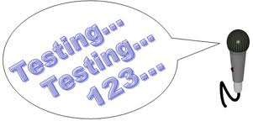
For those working in the mental health field, there are a variety of clinical measurement tools available to evaluate results. These are discussed in more detail at Level 2 and Level 3. If you’re using EFT as a stand-alone therapy or with therapies that don’t require evaluation (though we’d prefer you did) you can use the SUD or VOC scale to measure the level of intensity around the emotion. Testing can be done at the beginning or end of a session, after
every round or where there has been a change of an aspect or an issue. Some can be very imaginative. Here are some ideas:

Be a little provocative…… Ask questions
Test out how they react to their “trigger” by asking questions such as

- So tell me again, what names did they call you at school?
- How will react when you see your ex in the street?
- Can you describe how you felt when you got the phone call?

Use vivid imagination

If they got an anxiety attack when they looked at a letter or an email, ask them what they think they would feel if they were to look at it again. Tap for any anxiety and when they feel calm….test it out. Ask them to imagine reading their Facebook message again (always a common one!) Ask them to imagine being in a situation. If they find this hard to believe it will work in real life, it might help to understand your subconscious doesn’t understand what’s real and what’s imagined. If you want to know how that works, just close your eyes and imagine cutting into a lemon, see the juices come out and take a bite!

Examples:
- You are in the exam room and the teacher says you may begin
- The plane is taxiing down the runway and you feel the lift off
- Your husband is looking at you in that put down way

If possible have them do what they couldn’t do before:
- Hold a spider (see below)
- Look at the scene in the movie that previously scared them
- Ask them to repeat the problem out loud

Warning: Always make sure the SUD level is at a zero before testing in a live situation and then only do it gradually - checking the SUD all the time. Keep a physical distance from the object, substance etc. Gradually adjust the distance or level of exposure.

Examples: taking them in a car, showing a video of a snake, taking them up in a lift. On no account should a client ever be distressed unnecessarily.

Truth Statement (Validity of Cognition scale)

When working with beliefs. The Validity of Cognition scale can be used to establish how much truth is in the statement. So for example, a statement that says “I’m to blame” may rate 8 on the VOC scale in terms of how much belief is in that statement. The aim would be to move this down to a zero = no belief in the statement at all.

“How much truth is in that thought?” (on the VOC scale) “How much doubt is there in that statement?” (on the VOC scale)

Creative scales of measurement
As the heading says, be creative – especially when using EFT on children

“ Can you show me with your hands, how big is it?” “ Is that in the green, amber or red zone?”
“ What percentage out of a 100 would you give that?”
You can use height charts, rulers or any other measurements.

Testing is an essential part of the EFT process because Practitioner and client can ascertain whether any more work needs to be done.

EFT FOR TRAUMA


Whilst we do not advocate Level 1 students work on others, this information is for those who are prepared to take EFT to the next level of training. Almost every client who seeks help has probably been traumatised to some degree or another and we strongly suggest EFT students and Practitioners undergo appropriate training.

As evidenced by clinical studies and testimonies, EFT is very effective in dealing with the symptoms associated with the various forms of trauma, particularly Post Traumatic Stress (Disorder).

Trauma causes a high emotional and/or physical reaction. Until recently psychological trauma was noted only in men after catastrophic wars. The women's movement in the sixties broadened the definition of emotional trauma to include physically and sexually abused women and children. Now, because of the discoveries made in the nineties - known as the decade of the brain - psychological trauma has further broadened its definition further to include loss of job, divorce, moving house etc.

Trauma is generally defined as

- it was unexpected;
- the person was unprepared; and
- there was nothing the person could do to prevent it from happening

EFT provides a range of approaches to clear the emotion of traumatic memories gently and effectively. These approaches are listed below and are taught at Levels 2 and again at Level 3.

Movie Technique Tell The Story Tearless Trauma
Sneaking up on the Problem


ABREACTION

Accidently accessing a repressed memory may create an overwhelm of emotion – also known as an “abreaction”. An
abreaction is a normal but intense emotional reaction to a specific stimulus and is most likely to occur when the client has suffered or continues to suffer from intense emotions that have been buried or repressed.

There can be separate, though intimately connected, memories involved with any form of repression.

  - Visual
  - Physical
  - Emotional
  - Belief
They are entirely separate memories and each may 'surface' together or individually. It is not unusual for a client to recall, in one session, a physical sensation of some sort so strongly that they can actually feel it, yet not discover the emotional response or the exact nature of the event until their next session or even the one after that.

Warning: Accessing parts of the memory can be so realistic, as far as the client is concerned, that their body will actually reproduce the physical changes that occurred at the time of the event; if there was an element of suffocation, for example, your client may suddenly find great difficulty breathing - or may even stop breathing for a few moments. If they were physically abused in some way, then they may well feel that same abuse - or the results of it - whilst in your chair, just as if it were happening to them right at that very moment.

A client may scream, shout, sob, sweat, shake violently, curl up into a foetus or gag... it can be a truly unnerving experience for the unwary!

Of paramount importance is the safety of your client. For example, if they have reacted to a physical memory (say, of being hit) then they may not want to be touched during their abreaction

If a client feels faint, ask them to put their head between their knees and breathe slowly, offer a glass of water when they’ve recovered. Sometimes the client will know what is right for them.

What to do :
- Do not tap unless they give permission
- If they do then continue to tap on all the points up and down the body
- Stay calm and confident
- Go at the client’s pace and do not rush in to “fix” them
- Use “accelerator and brake”
- Ask them to keep them firmly on the floor as if rooted to the ground
- Remind them that whatever is happening in their mind is not happening now. It is only a memory.
- Avoid any “trigger” words – keep neutral and global “this intense emotion” for example
- If they have their eyes closed, ask them to open them and reassure them that they are in the room, you are there and they are safe.

If an emotional overwhelm/abreaction occurs during a demonstration you are giving – just follow the advice above. Ask the volunteer if they would like to go to another room to rest.

WHEN THEY HAVE CALMED DOWN

Abreactions often bring a huge release, a big cognitive shift and a major insight into the problem so when they have calmed down sufficiently, ask if you [or they] can gently tap for “even though that was overwhelming, and I wasn’t prepared for it…I thank my body for bringing it up” or something like that.

You could tap for any residual physical feelings such as “this racing heart” or “these breathing problems”. You can tap on both sides of body and you can use any points in any order.

- If they apologise, reassure them it’s OK to cry or get upset. There should be no embarrassment.

- Ask if they want to have a break or terminate the session and reschedule

- Always make sure they’re left feeling OK

- Leave instructions on who to contact if they need help.

More safety techniques are taught at Level 2 Intermediate.

EFT FOR PHYSICAL SYMPTOMS

It is known and accepted by many hospitals in the West, as well as in China (where acupuncture originated) that certain acupuncture points can have an extraordinary effect in reducing the amount of pain that people experience.
Therefore, it is not surprising that since there is a strong parallel between the points used in EFT and some traditional acupuncture points, that EFT should have an alleviating effect on bodily pain.

However, EFT seems to do much more than reduce pain when it is effective for a physical condition. In a surprising number of instances it is far more helpful than one might expect it to be. Probably the most likely explanation for this is the existence of the mind-body connection which is now being widely known as Psychoneuroimmunology (PNI) which studies the interaction between psychological processes and the nervous and immune systems of the body. When an emotional issue has been cleared, often any physical symptoms disappear also.

When using EFT on pain remember these key questions:-

  - When did it begin?
  - What was going on in your life around that time?
  - What does the pain remind you of?
  - Describe exactly where it is. “Right shoulder blade”
  - Use their exact words. So if they say “this aggravating bursitis” or “angry red pain” you use those words
  - How they describe it. Not just “this knee pain” but “this throbbing pain in the back of my left knee”. What kind of “ache” is it?
  - Is there an emotion attached to this symptom?
  - What triggers it off?
  - How do you want to feel or what do you want to be able to do?
Example: “Even though I have this angry pulsating pain in the top of my right arm….I accept myself.” Or “Even though I have this throbbing pain across my forehead ….I accept myself”.

They may say “I have this pain here” so you would ask “what type of pain and how would you describe that area?”

Warning: Do not claim to cure cancer or other serious diseases unless you are medically qualified to do so. Please check up on the laws in the country you practice in when working with physical issues.
How to use EFT on physical issues is taught at Level 2.

ADDICTIONS AND CRAVINGS

“The true cause of all addictions is anxiety …an uneasy feeling that is temporarily masked, or tranquillised, by some substance or behaviour” Dr Roger Callaghan

When our emotional needs are not met, it’s human nature to seek comfort in other ways in order to “self -medicate” or “self soothe”. These comforting habits can become addictive and difficult to stop. EFT can work on cravings and addictions but it does take persistence and often requires searching for the underlying cause. When did the obsessive behaviour start? What was going on in their life at the time? When do they need to carry out the behaviour? How would they feel if they couldn’t carry out the behaviour?

EFT works very effectively on cravings and addictions though. What to tap on:-
Cravings

A good starting point in working with addictions is the experience of needing the behaviour or substance. Ask “what does it feel like when you want it?” “Can you get that feeling now?” and then do a few rounds of EFT. Ask them “Will that feeling still come back?” keep tapping until they can’t get the feeling. Test if you can with the substance. Teach them how to do EFT for themselves and suggest they repeat the tapping every hour for the next few days. (They need to be well motivated to do this).

Beliefs and capabilities

I can’t manage without XXXXX
My life won’t be worth living without XXXX I don’t believe this will work
I’ll lose my friends if I give XXXX up
Triggers

“When do you most want to do that?” “Where are you when you get tempted?” Do several rounds of EFT on whatever are the main triggers having them first vividly imagine being in that situation. Test by vividly imagining the trigger and noticing the changed response.

The Implicit Emotion

“How do you feel emotionally when you want it?” “What is it in your life makes you feel like that?” People often use addictive behaviour as a short- term tranquilliser of strong emotions. I feel angry so I drink, I feel nervous so I smoke. Use EFT on the situations that give rise to the emotions. You can also use EFT on their feelings about the behaviour and use EFT Choices (Advanced course) to install more useful “self “ statements.

Memories and Trauma

Ask when the behaviour started and what was going on in their lives then. What started as a way of coping with difficult times may now persist as a bad habit. Use the Movie Technique or Tell the Story to de-traumatise any intense memories. Family rules can lead to addictive behaviour. Ask about other members of the family or the family culture regarding the behaviour. Use EFT on whatever arises.
Future

Often if a behaviour has persisted for some time the person cannot see a future without it. Look for blocking beliefs such as “It’s not safe for me to get better”. Tap on their doubts, fears and uncertainties and help them to see that they are creating their own future. When these feelings are reduced, get them to imagine themselves free of the addictive substance/behaviour and tap on that feeling.
Persistence

PR is almost always present with addictions so bring in the Full Routine, tap on both sides. If a craving comes back it’s because the underlying emotional aspect hasn’t been cleared. The more EFT is used on the craving, the weaker the urge becomes and the longer it takes to return.

Remember to use EFT:-

    - Before the urge

    - When feeling the urge

    - During giving in to the urge (if possible)

    - After giving in to the urge (guilt, remorse, shame)

EFT FOR CRAVINGS

Having witnessed the demonstration on using EFT for a craving and how others can “borrow benefits” from the exercise, you may want to experiment with this exercise.

REMEMBER... tap when you are experiencing the craving.

- Rate your urge or the intensity of the craving, on a scale of 0 to 10. Example: I feel like having a piece of cake at an intensity of 8 (0 = I do not crave having a piece of cake at all and 10 = I desperately want to have a piece of cake!)

Make sure you fully associate with the food, snack item or beverage. Locate the feeling or sensation in your body associated with this craving. Think about the item you are craving, get a mental picture and imagine it in detail, think about its aroma, its texture i.e. how it would feel in your mouth. Go into as much detail as possible. Include what it reminds you of if it helps.
- Start with the Set up (KC or SS) “Even though I have this craving in my (area in body where you feel the craving i.e. mouth, stomach etc)… I still want to deeply and completely accept myself.” (Repeat 2 more times) Note: Sometimes it is more effective if you do not what it is but describe how the craving feels.

- Now do the 'Sequence' as you focus on the feeling in your body.ToH – This craving EB - This craving SE - This craving UN - This craving CH - This craving CB - This craving UA - This craving

- Rate your craving intensity again (i.e. check the sensation in your body associated with the craving). If it is greater than a 2 (i.e. 3 to 10) do another round of tapping with the following changes:

Do the set-up 3 times: KC - Although I have this remaining craving… I deeply and completely accept myself. (Repeat 2 more times) Then do the body points sequence again using the reminder statement... "this remaining craving".

- Continue doing EFT rounds (set-up and sequence) until the urge or craving subsides to 0 or at least to a 1 or 2. If SUD is not going down:-

  - Introduce the Finger Points and the 9 Gamut.
  - Ask how they feel when they can’t have the item
  - Introduce the questions as above.
  - Work on the earliest memory associated with the craving

Note: If you find the craving coming back very quickly (and you are eating healthfully and drinking enough quality liquids) then go back to the root cause or driver. They are all great issues or subjects to tap on and remember to be very specific about what you tap on.

BORROWING BENEFITS

While working on a volunteer in an open session, Gary Craig discovered by accident that when the audience tapped along at the same time, their issues reduced or cleared, even though their issues were different to the volunteer’s up on the stage. The term became known as “borrowing benefits” simply because it’s possible to benefit from someone else’s session.

Clients who attend a Borrowing Benefits session can find it cost effective!

When using EFT on someone else it’s possible for your own issue to be resolved or be triggered which is why it’s important to clear your own issues before working on someone else.

You will have experienced Borrowing Benefits during the course and a full explanation of this concept and how you can conduct a Borrowing Benefits session will be given at Level 2.

GETTING MORE SPECIFIC THE MOVIE TECHNIQUE
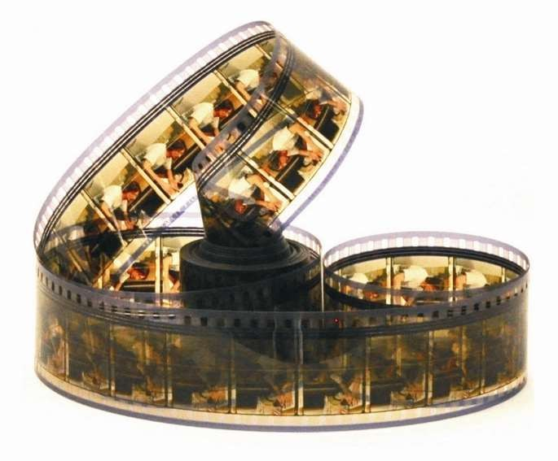

The reason that we put such key emphasis on this is that it combines many of the methods that are key to success with EFT.
The first thing the Movie Technique does is focus the client on being specific. EFT is great at eliminating the emotional intensity you feel, as long as it's used on an actual concrete event ("John yelled at me in the meeting"), rather than a general statement ("My procrastination").

The Movie Technique has the client identify a particular incident that has a big emotional charge for the client, and systematically reduce that charge to zero.
The client pictures the event in their mind's eye just as though it were a movie, and run through the movie scene by scene.
Whenever you reach a part of the movie that carries a big emotional charge, you stop and perform the EFT sequence. In this way, you reduce the intensity of each of the bad parts of the movie.
EFTs related technique, Tell the Story, is done out loud, while the Movie Technique is typically done silently. You can use the Movie Technique with a client without them ever disclosing what the event was.

Please note that is vitally important to keep client dissociated with the movie You can do this a number of ways.
By inviting them to pretend in their minds eye to sit at the back of a cinema, or a hot air balloon far away, glass partitions, be creative with this make sure that the client does not step into the movie.

Now let's add EFT to the movie. Here's the way you do this:
Find a specific event and take a bit size chunk of the zap intensity, no more than 3 minutes. Make sure the client is disassociated from the event.
- Ask the client to think of a title of movie. Rate the intensity of their emotional distress around just the title, not the movie itself. For instance, on the distress scale of 0 to 10 where 0 is no distress and 10 represents maximum distress, they might be an 8 when they think of the title "The Meeting." Write down the movie title, and the number.
- Work the movie title into an EFT "Setup Statement." It might sound something like this: "Even though [Insert Your Movie Title Here] I deeply and completely accept myself." Then tap on the side of your hand, known as the “karate chop” point/ side of hand while repeating the setup statement three times. Then tap through the rest of the EFT tapping points, repeating the title of the movie as you tap each one. The distress level will typically go down. You may have to do EFT several times on the title for it to reach a low number like 0 or 1 or 2.
- Once the title reaches a low number, ask the client to think of the "neutral point" before the bad events in the movie began to take place.For John, the neutral point was when he was walking home from school, before the bullies saw him. Once you've identified the neutral point of their movie, start running the movie through your mind, until you reach a point where the emotional intensity rises. In John's case, the first emotionally intense point was when he saw the bullies.
- Stop at this point, and assess your intensity number. It might have risen from a 1 to a 7, for instance. Then perform a round of EFT on that first emotional crescendo. For John, it might be, "Even though I saw the bullies turn toward me, I deeply and completely accept myself." Use the same kind of statement for your own problem: "Even though [first emotional crescendo], I deeply and completely accept myself." Keep tapping till your number drops to 0 or near 0, perhaps a 1 or 2.
- Now ask client to rewind the mental movie to the neutral point, and start running it in their mind again. Stop at the first emotional crescendo. If they sail right through the first one you tapped on, you know you've really and truly resolved that aspect of the memory with EFT. Go on to the next crescendo. For John, this might have been when

they shoved him into the gutter. When the client finds their second emotional crescendo, then repeat the process. Assess their intensity number, do EFT, and keep tapping till their number is low. Even if your number is only a 3 or 4, stop and do EFT again. Don't push through low-intensity emotional crescendos; since you have the gift of freedom at your fingertips, use it on each part of the movie.
- Rewind to the neutral point again, and repeat the process.
- When the client can replay the whole movie in their mind, from the neutral point, to the end of the movie and their feelings are neutral again, you'll know they have resolved the whole event. You'll have dealt with all the aspects of the traumatic incident.
- To truly test the work, run through the movie, but exaggerate each sensory channel. Imagine the sights, sounds, smells, tastes and other aspects of the movie as vividly as you possible can. If they have been running the movie silently in your mind, speak it out loud. When you cannot possibly make yourself upset, you're sure to have resolved the lingering emotional impact of the event. The effect is usually permanent.

WORKING ON YOUR OWN ISSUES


“The simplicity of EFT enables us to be both client and therapist.”

You are only at Level 1 but even so, it’s important that you work on your own issues before helping others to prevent your own “triggers” getting in the way. Gary Craig referred to this as the “Personal Peace Procedure” found on the next page.

Do whatever works for you, here are some suggestions:

Write down all the issues that are or have bothered you regardless of how big or how small. There should be 100’s of these.

Give each one a number using the SUD scale

Find a quiet place where you won’t be disturbed.

Start tapping on the biggest number and you will notice as you work through that the smaller numbers may not be as intense – if there is any emotion there at all!

Be persistent with physical issues and make tapping a daily habit

Keep a notebook and write down triggers, memories, writings on walls for later. Or use art and draw, paint or play and tap on what comes

Note….

Speak out loud so that you not only think but you hear your words (it’s a different part of the brain).

Work with a mirror so that you can see yourself

Sometimes you may not notice the changes or there may be a delayed effect.

PERSONAL PEACE PROCEDURE
Gary Craig

The Personal Peace Procedure (PPP) is not just a way to ‘feel a little more peaceful.’ Properly understood, this technique should be the healing centerpiece for every person on earth. Every physician, therapist, spiritual counselor and personal performance coach in the world should be using it as a leading tool for helping others (and themselves).’

In essence, the Personal Peace Procedure involves making a list of every bothersome SPECIFIC EVENT in one’s life and systematically EFT’ing their impacts out of existence. By diligently doing this we can pull out every negative tree from our emotional forests and thus eliminate major causes of our emotional and physical ailments. This, of course, propels each individual toward personal peace which, in turn, contributes mightily toward world peace. Here are some uses…

- As ‘homework’ between sessions with a Practitioner. This is certain to accelerate and deepen the healing process.
- As a daily procedure to clear out a lifetime of accumulated emotional debris. This will enhance self-image, reduce self-doubt and provide a profound sense of freedom.

- As a means to eliminate a major contributor (if not the sole cause) of a serious disease. Somewhere within one’s specific events are those angers, fears and traumas that are manifesting as disease. By addressing them all, you will likely cover those responsible for the disease.

- As a useful substitute for finding core issues. If you neutralize all the specific issues you will have automatically included core issues.
- As a means for consistent relaxation.
- To become an example to others as to what is possible.
This simple concept should shift the entire healing World. I can state it in a sentence…
“Most of our emotional and physical problems are caused (or contributed to) by our unresolved specific events, the vast majority of which can be easily handled by EFT.”

WHAT DO I DO IF I’M NOT GETTING ANYWHERE?


At Level 1 you will only have covered the foundations of EFT but you should still be getting some results on minor issues. Here are some ideas to help you;

Be PERSISTENT. Have you missed anything or could you try a different approach?

Use emphasis when saying the Set Up phrase. If angry, show anger!

Rub the Sore Spot more vigorously

Don’t underestimate the important of drinking more water both therapist and client!

Get more SPECIFIC

Check for any reversals or secondary gains

Look for any hidden aspects

Remove mobile phones, jewelry, move away from computers

Break State (shake body and move about)

Do they have any allergies or toxins (sugar, coffee, pesticides, chemicals)

Lack of training and experience can account for poor or slow results. There is no substitute for good quality training.

USEFUL READING MATERIAL and Scientific Links



- Rapid Treatment of PTSD: Why Psychological Exposure with Acupoint Tapping May Be Effective, David Feinstein, PhD, Psychotherapy: Theory, Research, Practice, Training (2010)
- The Neurochemistry of Counterconditioning: Acupressure Desensitization in Psychotherapy, James Lane, PhD, Energy Psychology: Theory, Research, & Treatment (2009)
- The Dream to Freedom Technique, a Methodology for Integrating the Complementary Therapies of Energy Psychology and Dreamwork, Robert J. Hoss and Lynne M. Hoss, DreamScience Foundation, Energy Psychology: Theory, Research, & Treatment (2010)
- Energy Psychology in Rehabilitation: Origins, Clinical Applications, and Theory, Fred Gallo Ph.D, Energy Psychology Journal (2009)
- Why Tapping Works: A Sense for Healing, Speculations from an Observable Brain, Ronald A. Ruden, M.D. Ph. D. Healing the Mind.net (2005

- Emotional Freedom Technique for Dummies: Helena Fone
- Systemic Energy: A New Perspective: Zoltan Apathy
- Healing the Shame that Binds You: John Bradshaw
- The Biology of Belief: Bruce Lipton
- Quantum Healing: Deepak Chopra
- Feelings Buried Alive Never Die: Karol Truman
- The Field: Lynne McTaggart
- The Body Remembers: Babette Rothschild

EFTi Scientific References & Recommended Reading
This document provides reference links and citations often cited by EFT International for educational, accreditation, and evidence-based practice purposes. Trainers and students can use these for deepening understanding and standardisation in clinical settings.
- Energy Psychology: Efficacy, Speed, Mechanisms
Feinstein, D. (2012)
Link: https://doi.org/10.9769/EPJ.2012.4.1.DF
- Meta-analysis of Emotional Freedom Techniques (EFT) treatment of depression
Clond, M. (2016)
Link: https://doi.org/10.1016/j.explore.2016.06.001
- The Effect of Emotional Freedom Techniques on Stress Biochemistry
Church, D., Yount, G., & Brooks, A. (2012)
Link: https://doi.org/10.9769/EPJ.2012.4.3.DC
- Feinstein’s Response to Critics of Energy Psychology
Feinstein, D. (2019)
Link: https://energypsychologyjournal.org/response-to-critics/
- EFT International Practitioner Guidelines
EFT International
Link: https://eftinternational.org/discover-eft/eft-research/
- Getting Specific with EFT – Why it Matters (Trainer Article)
Betty Moore-Hafter, M.Ed.
Link: https://eftinternational.org/training/accredited-eft-training-materials/specificity-in-eft/
- Energy Psychology Research Summary (EFTi)
Compiled by EFTi
Link: https://eftinternational.org/discover-eft/eft-research/research-summary/



WHAT NOW?
EITHER OR BOTH

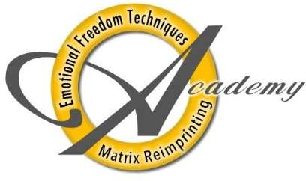


Congratulations on completing Level 1 Foundation training in EFT. I hope you are now enthused to progress to Level 2 where you will be introduced to other EFT techniques that you can utilize for different scenarios You will also learn how to apply EFT to pain, trauma, phobias, on children and animals and much more.

Please now take the time for self evaluation on next page

Penny Croal

penny@changeahead.biz

EFT Level 1 – Student Self-Evaluation

Please complete this form honestly at the end of your Level 1 training. This is for your own reflection and for discussion with your trainer or mentor. There are no “right” answers — this is about insight and integration.

Key:

✅ = Confident and clear
➖ = Some understanding, but needs practice
❌ = Unsure or needs further support
Learning Outcome | ✅ | ➖ | ❌ | Comments or Questions for Trainer
1. I can describe the origins, principles, and theoretical foundations of EFT
2. I can explain how EFT works from both energetic and psychophysiological perspectives
3. I can identify and apply the full Standard EFT Protocol and explain its purpose
4. I can demonstrate the Shortcut EFT Protocol appropriately
5. I can use the SUD scale and identify emotional intensity accurately
6. I can apply the Set-Up Phrase and Reminder Phrase with specificity
7. I can recognise common blocks (e.g., psychological reversal, energy toxins) and adapt as needed
8. I can explain and manage abreactions or intense emotions safely and effectively
9. I understand the concept of aspects and how they influence EFT effectiveness
10. I can conduct a basic tapping session on myself for emotional self-regulation
11. I can use EFT with others under supervision and within ethical limitations of Level 1
12. I understand the importance of specificity, testing, and recognising cognitive shifts
13. I can outline and begin to apply the Personal Peace Procedure for ongoing self-care
14. I respect confidentiality and understand how to establish clear, ethical boundaries with others
15. I can reflect on my own responses, triggers, and areas for professional growth

- Additional Notes or Questions for Mentoring Support:
- (Use this space to share anything you’d like feedback on, or areas where you feel unsure.)

- Would you like this formatted as a downloadable Word or PDF file? Or embedded directly into your manual?

